GABA_{B} receptor modulation in hPSCs-derived sensory neurons by baclofen and α-conotoxin Vc1.1
Arsalan Yousuf^{1,2}, Mitchell St Clair-Glover¹, Dominic Kaul¹, Mirella Dottori¹, and David J. Adams¹
¹ Molecular Horizons, Faculty of Science, Medicine and Health, University of Wollongong, Wollongong, NSW 2522 Australia.² Sydney Pharmacy School, Faculty of Medicine and Health, The University of Sydney, NSW 2050 Australia.

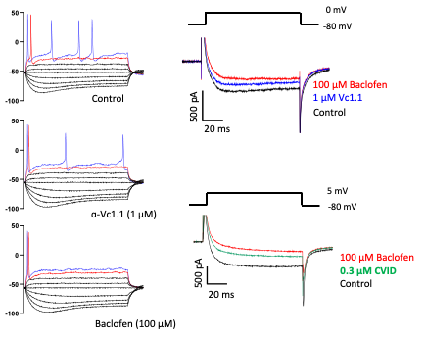
Emerging strategies to develop, study and characterise human pluripotent stem cell (hPSC)-derived sensory neurons present a favourable alternative to study pain relief. In this study, hPSCs were differentiated into DRG sensory neurons using a chemical and transcription factor-driven approach. Molecular characterisation by immunocytochemistry and qPCR showed differentiated sensory neurons express key markers such as BRN3A, ISLET1, and PRPH, in addition to GABA_{B}R and ion channels including Ca_{V}2.2, GIRK, and HCN channels. Functional characterization of GABA_{B}R was carried out using patch clamp electrophysiology, with neuronal excitability studied under current clamp conditions in the absence and presence of GABA_{B}R agonists, baclofen and α-conotoxin Vc1.1. Both baclofen and Vc1.1 significantly reduced membrane excitability by hyperpolarizing the resting membrane potential by ~-4 mV from -54 ± 4 mV (n = 10). In voltage-clamp mode, Vc1.1 and baclofen inhibited HVA Ca²⁺ channel currents by ~25% and 50% (n = 8), respectively, which was attenuated by the GABA_{B}R antagonist CGP 55845. Hyperpolarization-activated current was inhibited by selecteive HCN antagonist ZD7288. Transient expression of human GABA_{B} receptor subunits together with HCN1/2 channels in HEK293T cells confirm that baclofen and Vc1.1 potentiate HCN-mediated K⁺ currents. Overall, this study reports GABA_{B}R modulation of HVA Ca²⁺ channels and membrane excitability in hPSC-derived sensory neurons by baclofen and Vc1.1, which could pave the way for future cell models to study analgesic compounds.

Hulme, A. J., McArthur, J. R., … & Dottori, M. (2020). Molecular and functional characterization of Neurogenin-2 induced human sensory neurons. Frontiers in Cellular Neuroscience, 14(425).

