**Elucidating the Anti-Bacterial Potential of Gallic Acid Loaded Graphene Oxide (GAGO) Nanocomposites and the Mechanism of Action Involved for Management of Methicillin-Resistance Staphylococcus Aureus (MRSA)**

**Suhaili Shamsi,** Ida Ng May Jen, Doris Tan Xia Chin.

Laboratory of Animal Biochemistry and Biotechnology, Department of Biochemistry, Faculty of Biotechnology and Biomolecular Sciences, Universiti Putra Malaysia, Serdang, Selangor, Malaysia

**Background and aims.** Methicillin-resistant Staphylococcus aureus (MRSA) infection has emerged as a global concern due to its resistance to conventional antibiotics. Although vancomycin remains effective against MRSA, reports indicate increased MRSA resistance worldwide, including in Malaysia. Consequently, scientists have been seeking alternative treatments, with nanocomposites as promising alternatives due to enhanced stability, drug delivery efficacy, and synergistic antibacterial effects. The present study aims to investigate the stability of gallic acid-loaded graphene oxide (GAGO) nanocomposite and its antibacterial activity, against MRSA, as well as its impact on the cell membrane.

**Methods.** The drug loading of GAGO was monitored upon storage over 90 days, while its stability in various physiological media was monitored by measuring the zeta potential and morphology observation. The antibacterial activity of GAGO against MRSA was evaluated through colony-forming unit (CFU) counting method and time-kill experiment. The effect of GAGO on MRSA was investigated through dynamic light scattering (DLS) for membrane potential, FTIR for membrane composition changes, as well as high-resolution transmission electron microscopy (HRTEM) and field emission scanning electron microscopy (FESEM) for morphological changes. The mechanism of action of GAGO towards MRSA was further investigated by evaluating the membrane integrity, cellular leakage and ROS production.

**Results.** GAGO was synthesized successfully and remained stable upon storage over 90 days and across all physiological media. GAGO demonstrated significant antibacterial activity in the CFU method at concentrations of ≥150 μg/mL against MRSA, comparable to cefoxitin. Results have shown cell wall disruption and bactericidal activity of GAGO at 300 µg/mL. Besides this, GAGO at 150 µg/mL and 300 µg/mL disrupted and compromised the cell membrane of MRSA, leading to the leakage of intracellular constituents. In addition, GAGO has also exhibited potency in inducing the production of ROS in MRSA. Observations from FTIR and FESEM (Figure 1) further revealed compromised membranes in GAGO-treated cells.

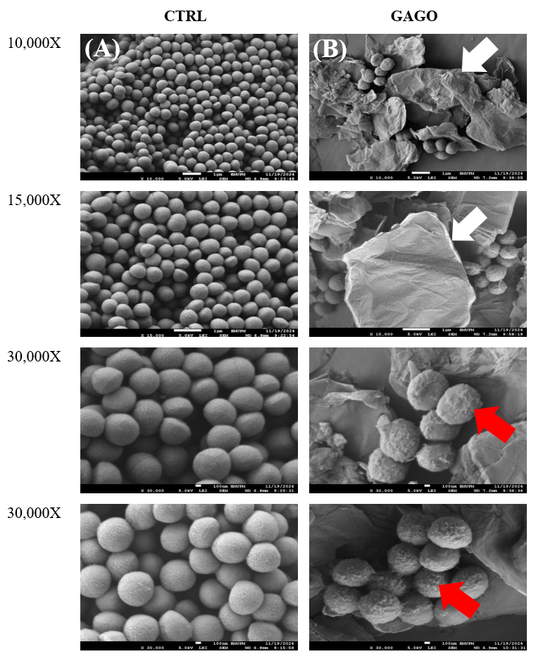

**Figure 1:** FESEM micrographs of (A) untreated MRSA (CTRL) and (B) treated MRSA with GAGO at 300 µg/mL. Scale bars represent 1 µm (10,000x and 15,000x magnifications) and 100 nm (30,000x magnification). White arrows indicate GAGO is wrapping MRSA, while red arrows indicate rough cell membranes following treatment with GAGO**.**

**Conclusion/Discussion.** Inconclusion, findings from the present study indicate the potential anti-bacterial properties of GAGO against MRSA through possible different mechanisms of action, but further study is warranted for the formulation to be developed in clinical settings as alternative for conventional antibiotics.

**References:**

(1) Ng, I. M. J., & Shamsi, S. (2022). Graphene oxide (GO): A promising nanomaterial against infectious diseases caused by multidrug-resistant bacteria. International Journal of Molecular Sciences, 23, 9096

(2) Shamsi, S., Abdul Ghafor, A. A., Norjoshukrudin, N. H., Ng, I. M., Abdullah, S. N., Sarchio, S. N., Md Yasin, F., Abd Gani, S., & Mohd Desa, M. N. (2022). Stability, toxicity, and antibacterial potential of gallic acid-loaded graphene oxide (GAGO) against methicillin-resistant Staphylococcus aureus (MRSA) strains. International Journal of Nanomedicine, 17, 5781–5807.