**Novel measurements of particle deposition in the human airway using optical coherence tomography**

**Zhiwei Shen1**, Taye Tolu Mekonnen2, Xinyu Cai1, Hak-Kim Chan3, Agisilaos Kourmatzis2, Shaokoon Cheng1

School of Engineering, Macquarie University, Sydney, NSW, Australia1;

School of Aerospace, Mechanical and Mechatronic Engineering, The University of Sydney, Sydney, NSW, Australia2;

Sydney Pharmacy School, The University of Sydney, Sydney, NSW, Australia3

**Background and aims.** Understanding the characteristics of particle deposition in the human airway, such as deposition thickness and distribution, is useful for evaluating the effectiveness of targeted nasal delivery. This study employs optical coherence tomography (OCT) to capture high-resolution cross-sectional images of particle deposition. This technique enables detailed analysis of how different particle properties influence their accumulation, and goes beyond the capabilities of conventional imaging methods, which are typically limited to two-dimensional visualisation.

**Methods.** Lactose particles of varying size and cohesiveness were administered into a transparent silicone replica of the nasal airway, reconstructed from Magnetic Resonance Imaging (MRI) data. Transient airflow at different peak flow rates was applied to simulate realistic breathing conditions. OCT imaging was used to quantify particle deposition at vestibule, turbinate and nasopharynx region, and data was reconstructed to analyse particle deposition thickness and their spatial distribution.

**Results.** Figure 1(a) shows the experimental setup. Figure 1(b) presents a real-time OCT image capturing the cross-section of deposited lactose particles (SV003). Figure 1(c) shows a three-dimensional reconstruction of the OCT images, illustrating particle distribution. The blue clusters represent the particles, while the grey section indicates the surface of the nasal replica. Figure 1(d) and (e) show the maximum thickness at location 1, reaching 230 µm at 55 L/min, which is 24% greater than that of SV003. This may be because the more cohesive nature of ML001 particles makes them less likely to break down into smaller sizes when dispersed via the nasal pump, resulting in larger agglomerates deposited in the nasal airway. The particle deposition patterns across different particle types suggest that the anterior section of the nasal airway is highly efficient at capturing particles.

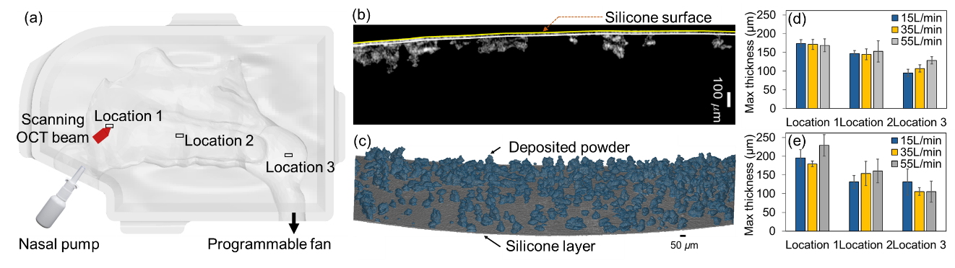

**Figure 1.** (a) Graphical illustration of the experimental setup; (b) Cross-sectional OCT image of particle deposition on the silicone nasal replica; (c) 3D rendered OCT image of SV003 particle deposition (blue) on the silicone nasal airway wall; (d, e) Quantitative representation of maximum deposition thickness at the three regions of interest for SV003 (d) and ML001 (e).

**Conclusion/Discussion.** This study provides the experimental quantification of particle deposition thickness in the human airway using OCT, revealing how flow dynamics, particle size, and cohesiveness affect deposition spatial pattern. The findings underscore the importance of particle and airflow characteristics in drug delivery design, and how it could be enhanced by the above demonstrated technologies.