**HAADF-STEM Study of Local Lattice Strain in Gold Nanoparticles**

*Syo Matsumura, Kohei Aso, Tomokazu Yamamoto*

Department of Applied Quantum Physics & Nuclear Engineering, Kyushu University, Fukuoka, Japan.

**Introduction**

Metal nanoparticles have attracted many research interests and are applied to various functional materials, such as optical devices, catalysts and so on. It is well known that lattice strain in nanoparticles affects the functional properties through local variation in the electron state. It is quite important to understand basic mechanisms to cause the local strain in nanoparticles. The present study was aimed to analyse systematically the local lattice strains in gold nanoparticles as a function of the aspect ratio by HAADF-STEM atomic resolution observations.

**Methods**

Atomic resolution HAADF-STEM observation was carried out using a JEM-ARM200CF at an acceleration voltage of 120 kV. We observed three nanoparticles which were almost same in width as ~9.0 nm but were different in length, or in the aspect ratio (AR) such as 1.0, 2.1 and 3.6. The coordinates of atom columns were determined in the images as the intensity peak positions of 2D Gaussian functions fitted to the image profiles of columns. The inter-columnar distances *d*1/2,1/2,0 and *d*001 were distributed around the mean values of <*d*1/2,1/2,0> and <*d*001> with the standard deviations less than 4 pm. Besides, molecular dynamics (MD) simulations were conducted for the corresponding shapes using LAMMPS with an Embed Atom Method (EAM) potential for Au [1,2].

**Results & Discussion**

Figure 1 shows an atomic resolution HAADF image of single-crystalline gold nanorod with AR=3.6. The [001] and [110] directions are set to the lateral direction *x* and the longitudinal direction *y* of the image, respectively. The ratio of lattice constants *c*/*a* (=<*d*001>/√2 <*d*1/2,1/2,0>) decreased with the increase of AR, as shown in Fig. 2. It indicates the crystal lattice is distorted to be tetragonal from *fcc* in the rod form. The MD simulations also showed the tetragonal deformation of crystal lattice corresponding well to the experimental results. It is concluded that the tetragonality comes from the anisotropic shape of the rod-like nanoparticles. Local displacements of atom columns were measured as deviations from the averaged periodic lattice points, and then the local strains *exx*(*x,y*) and *eyy*(*x,y*) were evaluated. Figure 3(a) gives the map of *exx*(*x,y*) in the nanorod with AR=3.6. It should be noticed that positive *exx*(*x,y*) about ~0.7 %, or dilatation strain along *x* direction, occurs localized in the tip parts in the nanorod. The MD simulation reproduced well the localized dilatation strain along the long axis in the rod shape, as shown in Fig. 3 (b).

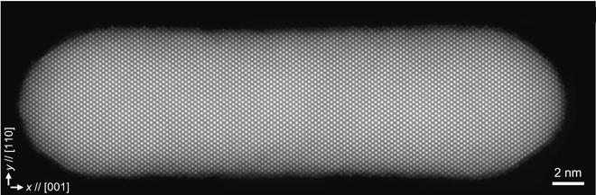

**Fig. 1.** HAADF image of Au nanorod with AR=3.6.

**References**

1. Plimpton, S. (1995). Fast parallel algorithms for short-range molecular dynamics. J. Comp. Phys., 117, 1-19.

**Fig. 3.** Strain maps of *exx*. Experimental (a), MD (b).

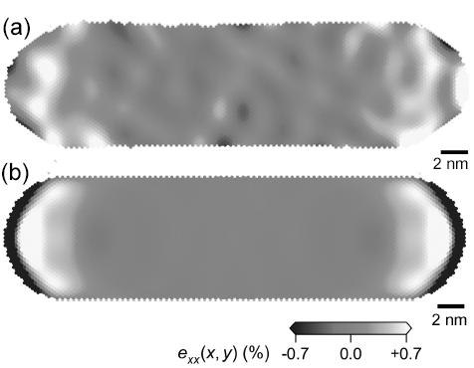

1. Purja Pun, G.P. (2017). Interatomic Potentials Repository, https://www.ctcms.nist.gov/ potentials/system/Au/

**Fig. 2.** Lattice tetragonality as a function of AR.

