**Particulate drug carriers modulate leukocyte adhesion in human blood flows**

William J. KelleyA, Peter J. OnyskiwA, Catherine A. FromenA, and Lola Eniola-AdefesoA,B

A University of Michigan, Department of Chemical Engineering, 2800 Plymouth Road, Ann Arbor, MI 48109,

B Corresponding Author

**Introduction**

Drug carriers have been widely explored as a method of improving the efficacy of therapeutic drugs for a variety of diseases, including those involving inflammation. However, very few of these formulations have advanced past clinical trials, and there are still major gaps in our understanding as to how drug carriers might impact leukocytes in the blood, particularly in inflammatory conditions.

**Methods**

In this work, we investigated how targeted and non-targeted drug carriers affect the function of leukocytes in blood flow through three primary mechanisms: (1) collisions in blood flow disrupting leukocyte adhesion, (2) specific binding to the endothelium competes with leukocytes for binding sites, and (3) particle phagocytosis alters leukocyte phenotype, resulting in reduced adhesion.

**Results**

We find for the first time that each of the three mechanisms mentioned above contributes to significantly reduced leukocyte adhesion to an inflamed endothelium (**Fig. 1**), dependent of particle concentration and size, and that particle phagocytosis may be the most significant driver of this effect. We find that internalization of particles leads to phenotypic changes in human neutrophils (increasing CD11b expression and decreasing CD62L expression) dependent on particle surface chemistry, which translate to faster leukocyte rolling velocity and reduced adhesion. Interestingly, these effects are magnified for nanoparticles with PEG coating, highlighting a functional difference between human and mouse neutrophils.

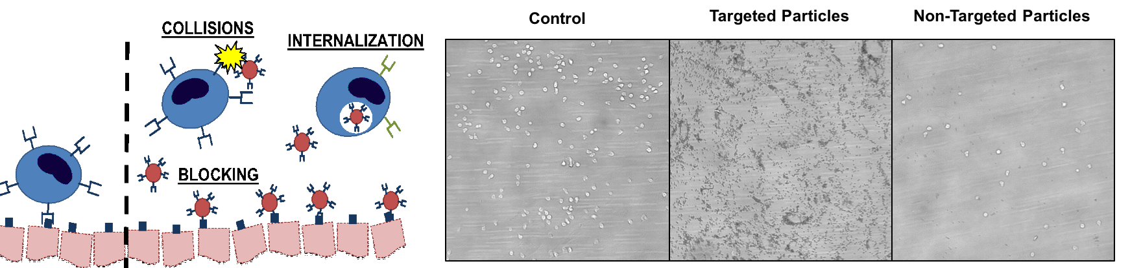

**Fig. 1.** Particulate drug carriers alter leukocyte adhesion to an inflamed endothelium via three primary mechanisms (left). Leukocyte adhesion to an inflamed endothelium in vitro with no particles and in the presence of targeted and non-targeted particles (right).

**Conclusion**

These results have significant impacts for the design and efficacy of vascular-targeted drug carriers and shed new light onto previously-unexplored effects of vascular-targeted carriers on circulating leukocytes, which may be leveraged for targeted treatment of inflammatory diseases.

Contact Email: lolaa@umich.edu