Design and applications of GPCR exoframe modulators
Yan Zhang. Department of Pharmacology, Zhejiang University School of Medicine, Hangzhou, China.
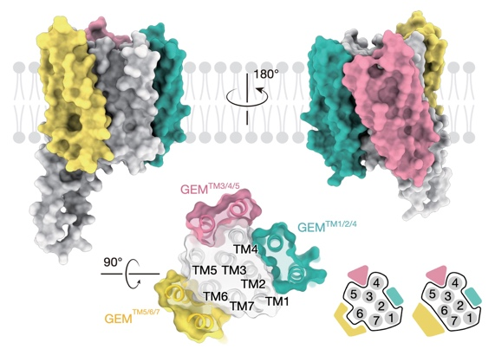
Introduction. G protein-coupled receptors (GPCRs) are pivotal therapeutic targets, traditionally targeted through orthosteric binding. However, allosteric modulation emerges as a promising and innovative strategy in the realm of GPCR drug discovery. Drawing inspiration from the natural regulation of GPCRs by transmembrane proteins, we have developed GPCR Exoframe Modulators (GEMs), de novo designed proteins that specifically target the transmembrane domain of GPCRs.
Aims. Designing novel transmembrane protein modulators to regulate signaling and to rescue the function of the mutants.
Methods. hallucination-like protein design, GPCR pharmocolgy, cryo-EM.
Results. Utilizing a cutting-edge hallucination-like design approach, we crafted GEMs with three strategic structural prompts to achieve the desired binding modes and functional outcomes. Structural studies and functional assay revealed that these GEMs bind to the transmembrane domain and elicit a spectrum of functional responses, including agonism, antagonism, and biased signaling. Most significantly, the agonistic GEM restores the activity of various loss-of-function mutants, heralding a novel and promising therapeutic avenue for GPCR-related disorders.
Discussion. Our work introduces TM-targeting GEMs as potent agents for allosteric GPCR modulation and highlights the potential of deep learning-based approaches in the design of function-oriented membrane protein. The GEMs may advance GPCR therapeutic development by providing conformationally-stabilized receptors that are crucial for structure-based drug design and deorphanizing ligand-less GPCRs.

