Enhancing abiraterone pharmacokinetics with lipid-based formulations: addressing solubility and food-effect challenges
Ali Taheri, Ruba Almasri, Anthony Wignall, Kristen E Bremmell, Paul Joyce, Clive A Prestidge. Centre for Pharmaceutical Innovation, UniSA, Adelaide, SA 5000, Australia

Introduction. Abiraterone acetate, a prodrug of abiraterone, is an effective anti-androgen for treating metastatic prostate cancer. However, its poor aqueous solubility restricts oral bioavailability to under 10% in fasted conditions. Additionally, its pharmacokinetics are highly variable and significantly influenced by a positive food effect, potentially impacting treatment safety and efficacy.
Aims. To develop a formulation strategy that enhances the fasted bioavailability of abiraterone and reduces its food effects by delivering the drug in a predissolved state.
Methods. Medium and long-chain self-nanoemulsifying drug delivery systems (MC-SNEDDS and LC-SNEDDS) were formulated with abiraterone acetate at 80% of its equilibrium solubility. The in vitro solubilisation performance was evaluated using a two-step, one-compartment gastrointestinal lipolysis model. In vivo pharmacokinetics were characterised in rats under fasted conditions and in pigs under both fasted and fed conditions.
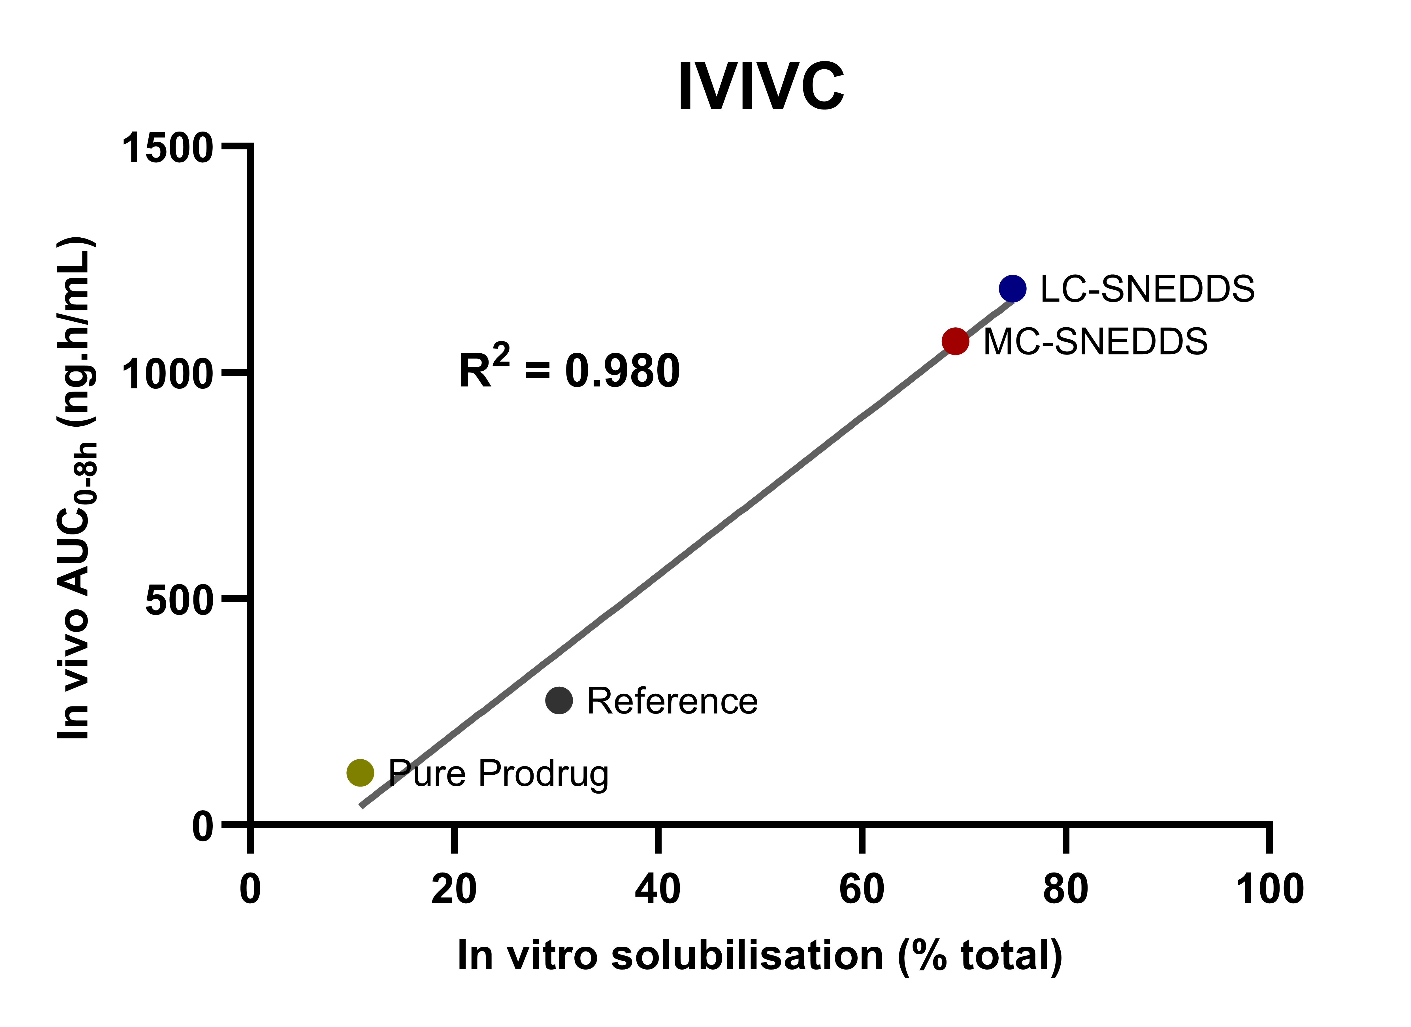
Results. The SNEDDS formulations increased in vitro solubilisation by over 6-fold compared to pure abiraterone acetate and over 2-fold compared to the reference. In rats, both MC-SNEDDS and LC-SNEDDS, along with their enteric-coated (EC) forms, demonstrated enhanced bioavailability, with EC-LC-SNEDDS providing the highest performance, showing a 7.3-fold increase in abiraterone exposure compared to the reference. In pigs, EC-LC-SNEDDS improved fasted bioavailability and reduced food effects, with a fed-to-fasted AUC ratio of 108%, compared to 334% for the reference.
Discussion. Our findings suggest that the developed lipid-based formulations have the potential to overcome abiraterone’s solubility-limited absorption and high PK variability, potentially offering improved outcomes for patients.

