**Fabrication and evaluation of amoxicillin trihydrate sustained-release gastro-floating tablets using semi-solid extrusion-based 3D printing**

**Seung Yeob Baeg1**, Young Soo Woo1, Ju Yeon Park1, Hyun Jong Park1, Dong Wuk Kim1

1College of Pharmacy and Research Institute of Pharmaceutical Sciences, Kyungpook National University, Daegu 41566, Republic of Korea

**Background and aims.** This study aimed to develop gastro-floating tablets (GFTs) containing amoxicillin trihydrate using semi-solid extrusion (SSE)-based 3D printing technology to improve drug delivery for Helicobacter pylori eradication.

**Methods.** Five paste formulations were prepared using amoxicillin trihydrate, hydroxypropyl methylcellulose (HPMC 2208) as a sustained-release matrix, microcrystalline cellulose (MCC) as an insoluble filler, polyvinylpyrrolidone K30 as a binder, and a mixture of D-mannitol and lactose monohydrate as soluble diluents. A 2:1 v/v mixture of ethanol and tertiary purified water was used as the dispersing medium. All formulations were printable and processed into elliptical cylindrical tablets with internal lattice structures. The printed tablets were evaluated for physicochemical properties, morphology, floatability, degradation, dissolution behavior, and release kinetics.

**Results.** AMX-3DP-GFTs were successfully fabricated across seven formulations (T1–T7). Among these, T6 exhibited the most stable release profile, achieving 82.5% cumulative release over 8 hours in simulated gastric fluid (SGF). Compared to the pure drug, T6 showed approximately two-fold slower release in SGF, indicating sustained-release behavior. Furthermore, at pH 4.0, T6 demonstrated prolonged drug release over 12 hours, outperforming the commercial reference product.

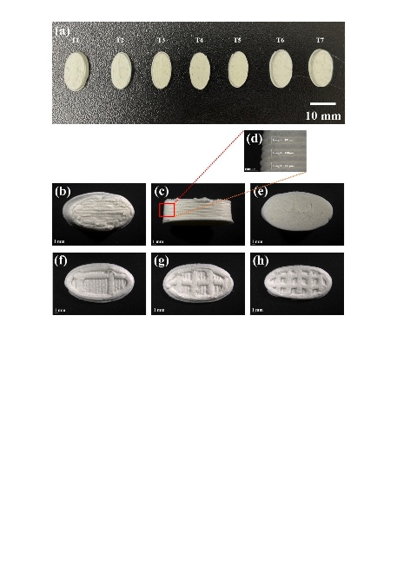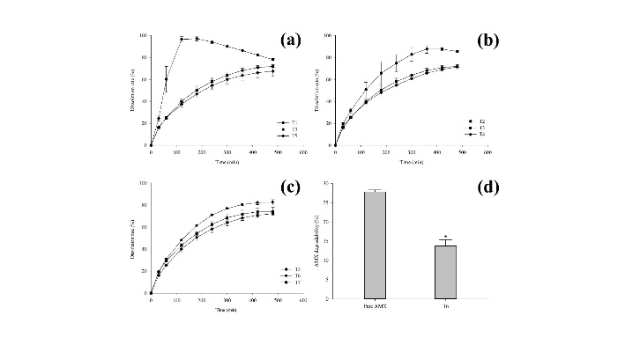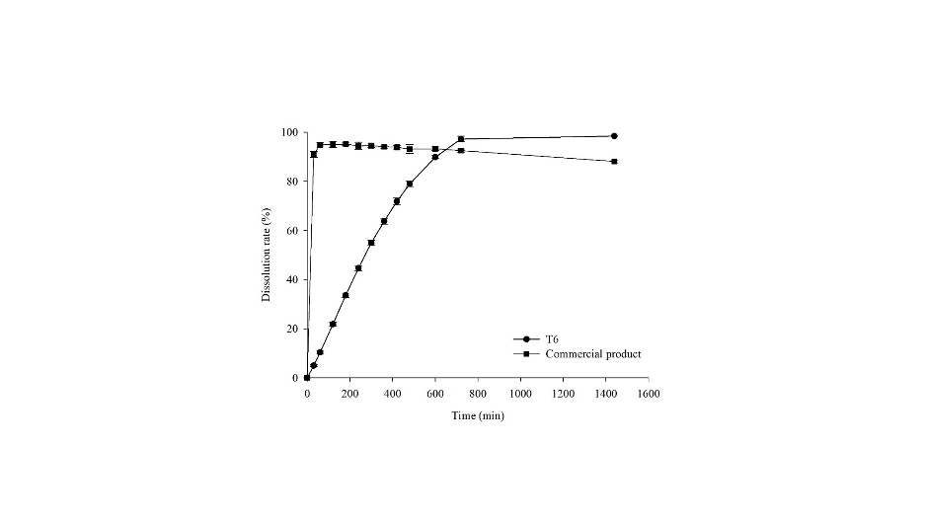

**Fig. 1.** Digital (a) and stereomicroscopic (b-h) images of AMX-3DP GFTs. (a), The appearance of AMX-3DP-GFTs; (b) Image of the top view in T6; (c) Image of the side view in T6; (d) Image of the more magnified side view (4x) in T6; (e) Image of the bottom view in T6; (f, g, h) Image of the cross-sectional view in T2, T3, T4. Magnification ratios were 0.75x unless otherwise specified. All images include scale bars.

**Fig. 2.** Dissolution rates of (a-c) pH 1.2 in AMX-3DP-GFTs and (d) degradability test at pH 1.2. (a), Effect of HPMC concentrations on dissolution rates in 3DP-GFTs; (b) Effect of infill densities on dissolution rates in 3DP-GFTs; (c) Effect of insoluble-soluble filler ratios on dissolution rates in 3DP-GFTs; (d) Comparison of amoxicillin acidic degradability between a pure AMX and T6. * p < 0.05 compared to pure AMX. Each value represents mean ± SD (n=3 or 4).

**Fig. 3.** Comparison of dissolution profiles between the commercial product and T6 in pH 4.0. Each value represents mean ± SD (n=3).

**Conclusion/Discussion.** These findings support the potential of SSE-based 3D printing as a novel platform for fabricating gastroretentive drug delivery systems. This approach may enhance the therapeutic efficacy of amoxicillin by extending gastric residence time, thereby improving outcomes in H. pylori eradication therapy.

**Acknowledgements:** This work was supported by the National Research Foundation of Korea (NRF) grants funded by the Korean government (No. 2020R1A5A2017323 and No. 2021R1C1C1010721).