**Engineered metal@carbon nanohybrids for enhanced carbocatalysis in environmental remediation**

*Dr. Xiaoguang Duan, Prof Shaobin Wang*

School of Chemical Engineering and Advanced Materials, The University of Adelaide, Adelaide, China.

The critical environmental issues urge advanced and green technologies for purification of contaminated water systems due to the existence of diverse hazardous organic substances produced from human activities. As promising candidates, carbonaceous materials have been extensively studied as green catalysts to replace the toxic transition/noble metal catalysts in environmental catalysis.

In this work, Prussian blue analogues (PBA) and metal organic frameworks (MOF) are engaged as the starting materials to fabricate various transition metal (TM)@carbon composites for water decontamination. The encapsulated metallic cobalt is unveiled to be more favorable to deliver electrons to the adjacent carbons than other cobalt species (e.g. CoP and Co3O4), due to the low work function, high conductivity and formation of multiple Co-C bonds for electron tunneling. Such a hybrid structure significantly tailors the electron density of the carbon lattice which is the decisive factor influencing activating peroxymonosulfate (PMS) to generate reactive sulfate radicals. These free radicals are highly oxidizing with a redox potential of 2.5-3.1V, which is capable of decomposing the organic contaminants into harmless compounds, carbon dioxide and water. Due to the carbon encapsulation, the metal core was prevented from leaching. Meanwhile, the metallic core can deliver electrons to the outer carbon sphere to enhance the carbocatalytic activity and assist carbon to resist surface oxidation, hereby achieving outstanding long-term stability. Deliberate material design and theoretical computations unveil the structure-activity regimes of the composite materials in promoted carbocatalysis. This proof-of-concept study dedicates to elucidating the principles in developing fine-tuned and high-performance TM@carbon hybrids for environmental catalysis.

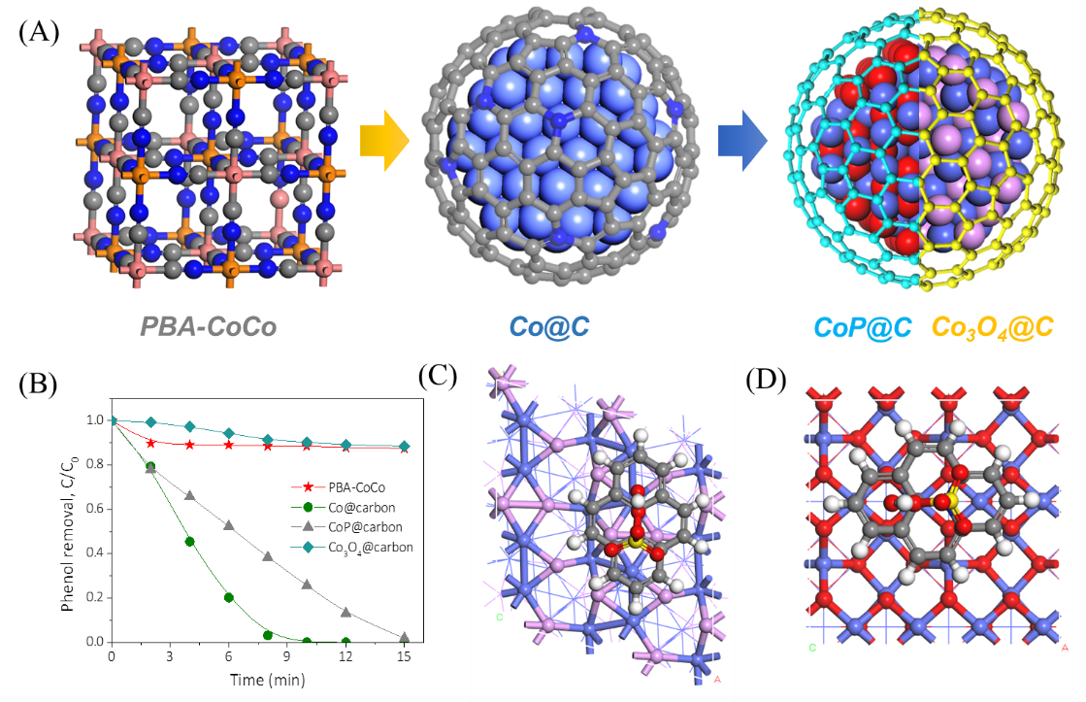

**Figure 1.** (A) Synthesis of various metal@carbon hybrids from PBA. (B) Catalytic performances of different Metal@carbon hybrids in catalytic activation of peroxymonosulfate and phenol degradation. Theoretical computation of peroxymonosulfate adsorption on (C) carbon@CoP and (D) carbon@Co3O4.

**References**

1. Duan X., Sun H., Wang S. (2018) Metal-free carbocatalysis in advanced oxidation reactions. *Account Chem. Res*. 51, 678-687.
2. Duan X., Wang S. et al. (2019). Interfacial-engineered cobalt@carbon hybrids for synergistically boosted evolution of sulfate radicals toward green oxidation. *Appl. Catal. B*, 256, 117795.