**Developing Highly Sensitive FKBPL ELISA for Preeclampsia Monitoring Using Gold Nanoparticles and Liposomes**

**Serah Nwoke1**, Iman Akbarzadeh1, Lana McClements1.

School of Life Sciences, Faculty of Science, University of Technology Sydney1, Sydney, NSW, Australia.

**Background and aims.** FK506-binding protein-like (FKBPL) is an emerging biomarker primarily secreted by endothelial cells and fibroblasts and is a key determinant of preeclampsia and cardiovascular disease. However, FKBPL is lowly secreted in human plasma and difficult to detect using conventional enzyme-linked immunosorbent assay (ELISA). Previous work has demonstrated one-order lower limit of detection for FKBPL using upconversion nanoparticles in a lateral flow assay compared to commercially available ELISA1. This study aims to develop and validate a highly sensitive nanotechnology-based FKBPL ELISA for monitoring preeclampsia and its cardiovascular sequelae, utilising gold nanoparticles (AuNPs) and liposomes.

**Methods.** Liposomes and AuNPs were synthesised via the thin-film hydration method and Turkevich method, respectively. The fabrication was optimised using the Box-Behnken design to assess the impact of independent variables on critical formulation responses, namely: trisodium citrate concentration and reaction temperature for AuNPs, and phospholipid-to-cholesterol ratio, lipid concentration, and sonication time for liposomes. Characterisation was performed by dynamic light scattering, Fourier Transform Infrared Spectroscopy (FTIR), and UV/Vis spectroscopy.

**Results.** The particle size, zeta potential, and polydispersity index of the optimal formulations were 25 nm, -35.2 mV, and 0.17 for AuNPs, and 100 nm, -41 mV, and 0.2 for liposomes. The FTIR spectra shown in Figure 1 confirmed the successful synthesis of AuNPs and liposomes. The UV/Vis spectra for AuNPs showed a maximal absorption peak at 527 nm, while the (free) liposomes did not absorb strongly in the UV-Vis range, as expected.

**Conclusion/Discussion.** These nanoparticles can be efficiently conjugated with anti-FKBPL monoclonal antibody pairs to develop a first-in-class, highly sensitive FKBPL ELISA kit. Once nanoparticle-based FKBPL ELISA is developed, it will be validated using plasma samples from women five years post-preeclampsia/gestational hypertension and normotensive controls (n = 89) to detect early changes in FKBPL reflective of undiagnosed cardiovascular disease in this high-risk cohort of women.

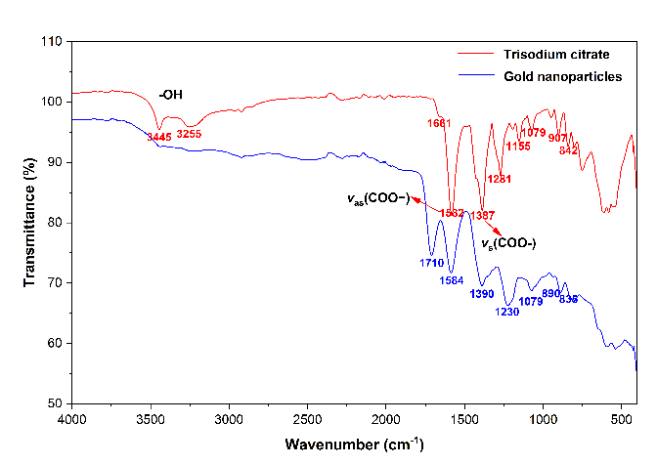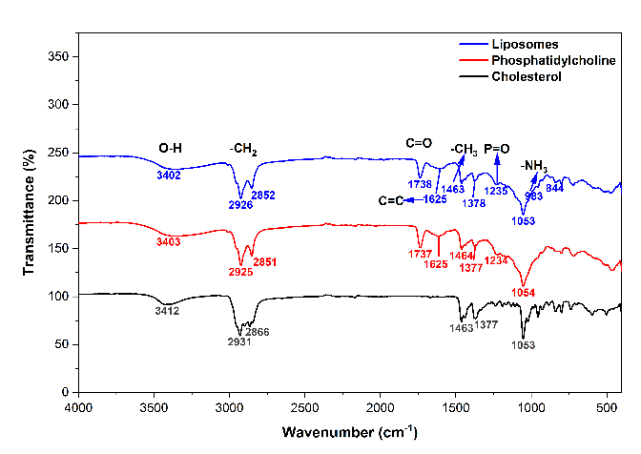

**a**

**b**

**Figure 1.** FTIR spectra of a) citrate-capped gold nanoparticles, b) liposomes and its components.

**References:**

(1) Masoumeh Ghorbanpour S, Wen S, Kaitu'u-Lino TJ, Hannan NJ, Jin D, McClements L. Quantitative Point of Care Tests for Timely Diagnosis of Early-Onset Preeclampsia with High Sensitivity and Specificity. Angew Chem Int Ed Engl. 2023;62(26):e202301193. doi: 10.1002/anie.202301193. PMID: 37055349