**Targeting bacterial endotoxin for treatment of sepsis**

**Richard D. Ye1,2**.

School of Medicine, The Chinese University of Hong Kong1, Shenzhen, Guangdong, China;

CUHK-Shenzhen Futian Biomedical Innovation R&D Center2, Shenzhen, Guangdong, China.

**Background and aims.** Antimicrobial resistance (AMR) is a global health threat due in large part to widespread use of antibiotics. Development of antibiotics-independent therapies for infectious disease is of high importance. To this end, we searched for endogenous proteins that can bind and neutralize bacterial endotoxins such as lipopolysaccharide (LPS) in an effort to prevent inflammatory cytokine storm and major organ failure in mouse models of sepsis.

**Methods.** Mouse models of acute lung injury and cecal ligation and puncture (CLP) were established. Human serum amyloid A1 (SAA1) was expressed in house as a full-length recombinant protein and peptide fragments. Transgenic (Tg) mice were generated to express human SAA1.

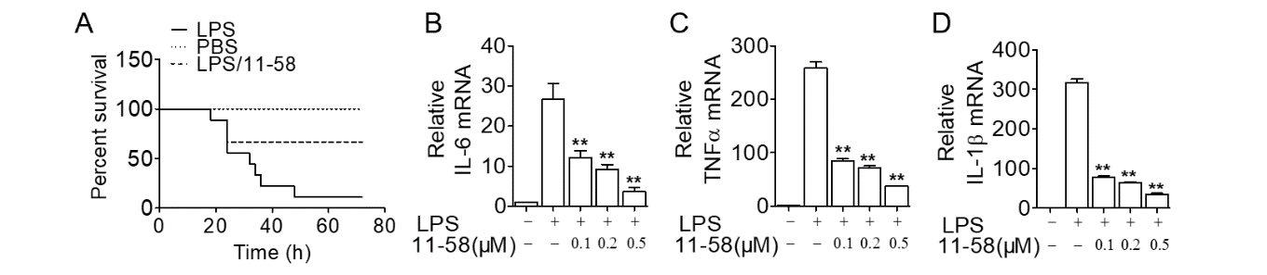**Results.** Transgenic expression of human SAA1 was found mainly in mouse lungs [1]. In mice challenged with CLP, the Tg mice displayed significantly improved survival compared to WT controls. Some of the SAA1 fragments also protected mice against LPS-induced acute lung injury (Figure 1A). In macrophages, LPS-induced inflammatory cytokine expression was abrogated by the SAA1 fragments (Figure 1B-D), indicating anti-inflammatory activity. Recombinant human SAA1 was found to bind LPS and form a complex that was internalized by macrophages, effectively reducing serum LPS concentrations.

**Figure 1.** SAA1 fragment 11-58 protects against LPS-induced acute lung injury and improves survival of mice (A). In macrophages, LPS-induced production of major inflammatory cytokines were abrogated by the 11-58 fragment (B-D).

**Conclusion/Discussion.** Induced expression of SAA1 during bacterial infection may serve an important function in innate immunity and host defence [2], in part through SAA1 binding of LPS for accelerated clearance by macrophages with reduced inflammatory response. Engineering of SAA1 fragments that target LPS may provide an alternative approach to treatment of sepsis induced by Gram-negative bacteria.

**Acknowledgements.** This work was supported in part by grants from Shenzhen Medical Research Fund (No. SMRFD2403009) and National Natural Science Foundation of China (No. 32070950).

**References:**

[1] Cheng N, Liang Y, Du X, Ye, RD. (2018) Serum amyloid A promotes LPS clearance and suppresses LPS-induced inflammation and tissue injury. **EMBO Reports** e45517. doi: 10.15252/embr.201745517.

[2] Chang Y, Liu Y, Zou Y, Ye RD. (2025) Recent Advances in Studies of Serum Amyloid A: Implications in Inflammation, Immunity and Tumor Metastasis. **Int. J. Mol. Sci.** 26, 987. doi: 10.3390/ijms26030987