MyCalPharm: Simulated Animal Experiments for Students of Pharmacology

Raveendran Ramasamy¹, Chandragouda R Patil². Department of Pharmacology, JIPMER¹, Puducherry, India; Department of Pharmacology, RCPIPER², Shirpur, India

Animal experiments were traditionally carried out during practical hours to teach drug actions to pharmacology students. In the 1990s, a movement to replace animals in teaching started in India. For more than thirty years, the authors created, distributed, and used computer-simulated animal experiments for medical and pharmacy students in India. Their software packages have helped students learn pharmacology and animal experiments without using animals in practical pharmacology.

Recently, the authors released a new package titled MyCalPharm (www.mycalpharm.com). It consists of 37 programs simulating animal experiments grouped into two sections, namely Xpharm and Xcology, which target medical students and pharmacy students, respectively. Each program, when run, displays the experimental setup and allows the user to interact with it through the mouse and the keyboard. The user can choose a drug from the list displayed and administer the same. The drug action is shown on the screen in animated sequences resembling a realistic experiment. The user can modify the dose to witness the dose-dependent effect. All programs (experiments) are provided with adequate text material and videos for some experiments to learn about the theoretical and dissection aspects of the experiment for better understanding. All the actions/responses/inputs of the user are automatically stored in a log file. The user can collect data, enter it in the tables provided, and store it. At the end of the experiment, the user is asked to answer a few questions. Once the experiment is completed, all data, including the logs, graphs (if generated), and answers, can be stored in PDF format and/or printed out. The file can be mailed to the teacher.

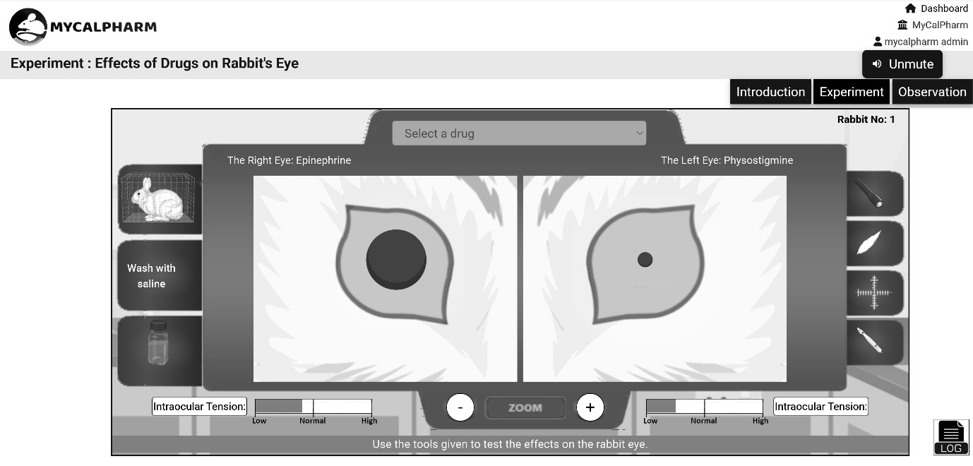
Screenshot of the rabbit eye experiment

Each experiment can be run in three modes: (a) Tutorial, (b) Examination Practice, and (c) Examination modes. Once the student is familiar with the experiment after running the program in tutorial mode, he/she can practice examination mode. In the examination mode, tasks are assigned to students who should find out the nature of the unidentified drugs using their knowledge gained using the tutorial mode. They can check their results by asking the program to reveal the unknown drugs at the end of the experiment. The examination mode is fully password-protected and meant for teachers to conduct examinations for students. The students should perform the experiment properly and carry out the tasks to find the answers. The unknown drugs can be revealed only to the teachers. A copy of the entire experiment is stored for the teacher to evaluate the same later. The software is user-friendly and realistic. It is widely used in medical colleges and pharmacy colleges in India for teaching medical and pharmacy undergraduates.

