**Silicon quantum processor unit cell operation above one Kelvin**

*C. H. YangA, R. C. C. LeonA, J. C. C. HwangA, A. SaraivaA, T. TanttuA, W. HuangA,*

*J. Camirand LemyreB, K. W. ChanA, K. Y. TanC, F. E. HudsonA,*

*K. M. ItohD, A. MorelloA, M. Pioro-LadrièreB,E, A. LauchtA, A. S. DzurakA*

ACentre for Quantum Computation and Communication Technology, School of Electrical Engineering and Telecommunications, The University of New South Wales, Sydney, Australia;

BInstitut Quantique et Département de Physique, Université de Sherbrooke, Sherbrooke, Canada;

CQCD Labs, QTF Centre of Excellence, Department of Applied Physics, Aalto University, Aalto, Finland;

DSchool of Fundamental Science and Technology, Keio University, Hiyoshi, Yokohama, Japan;

EQuantum Information Science Program, Canadian Institute for Advanced Research, Toronto, Canada

Quantum computers are expected to outperform conventional computers for a range of important problems, from molecular simulation to search algorithms, once they can be scaled up to large numbers of quantum bits (qubits), typically millions [1]. For most solid-state qubit technologies, e.g. those using superconducting circuits or semiconductor spins, scaling poses a significant challenge as every additional qubit increases the heat generated, while the cooling power of dilution refrigerators is severely limited at their operating temperature below 100 mK [2]. Here we demonstrate operation of a scalable silicon quantum p rocessor unit cell, comprising two qubits confined to quantum dots (QDs) at ∼1.5 Kelvin. We achieve this by isolating the QDs from the electron reservoir, initialising and reading the qubits solely via tunnelling of electrons between the two QDs [3]. We coherently control the qubits using electrically-driven spin resonance (EDSR) in isotopically enriched silicon 28Si, attaining single-qubit gate fidelities of 98.6% and coherence time *T*2* = 2 µs during ‘hot’ operation, comparable to those of spin qubits in natural silicon at millikelvin temperatures. Furthermore, we show that the unit cell can be operated at magnetic fields as low as 0.1 T, corresponding to a qubit control frequency of 3.5 GHz, where the qubit energy is well below the thermal energy. The unit cell constitutes the core building block of a full-scale silicon quantum computer, and satisfies layout constraints required by error correction architectures [4]. Our work indicates that a spin-based quantum computer could be operated at elevated temperatures in a simple pumped 4He system, offering orders of magnitude higher cooling power than dilution refrigerators, potentially enabling classical control electronics to be integrated with the qubit array [5].

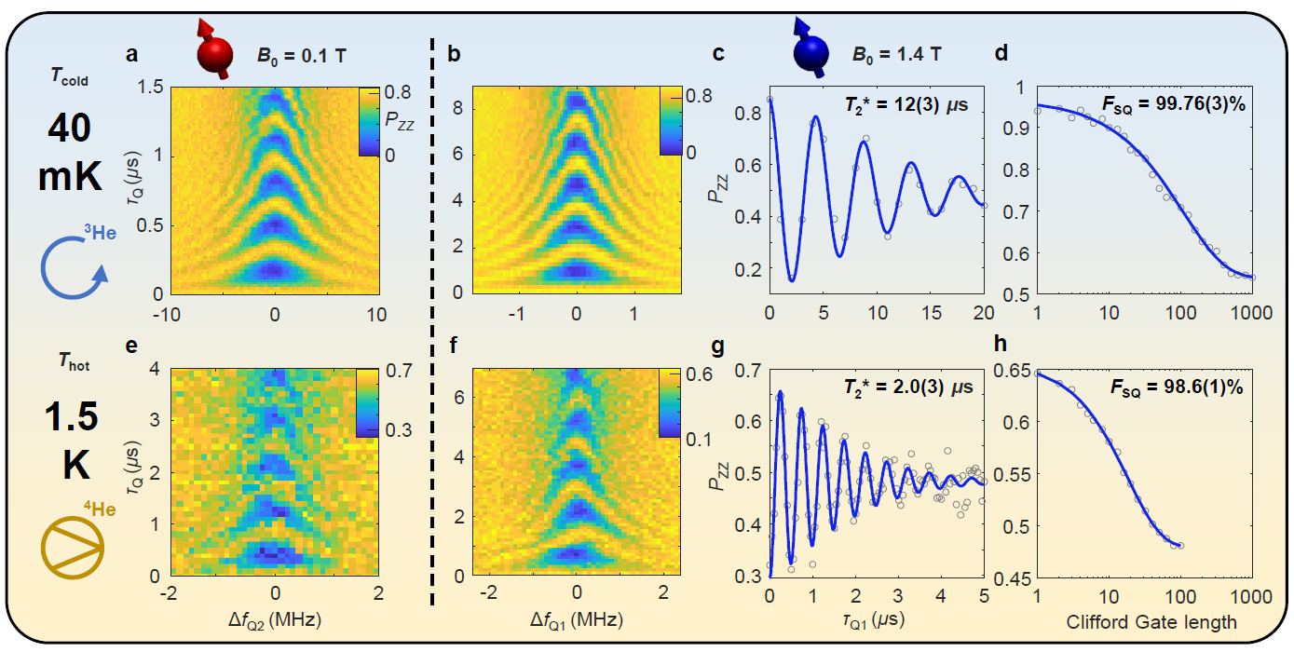

**References**

1. A. G. Fowler et al., *Physical Review A* **86**, 032324 (2012)
2. L. Vandersypen et al., *npj Quantum Information* **3**, 34 (2017)
3. B. Bertrand et al., *Physical Review Letters* **115**, 096801 (2015)
4. M. Veldhorst et al., *Nature Communications* **8**, 1766 (2017)
5. J. M. Hornibrook et al., *Physical Review Applied* **3**, 024010 (2015)