NAD(P)H:Quinone Oxidoreductase 1 (NQO1)-dependent synergistic therapeutic potential of Cryptotanshinone (CTS) and BBI608 in pancreatic cancer
Bingling Zhong, Xiuping Chen. State Key Laboratory of Mechanism and Quality of Chinese Medicine, Institute of Chinese Medical Sciences, University of Macau, Macao, China.
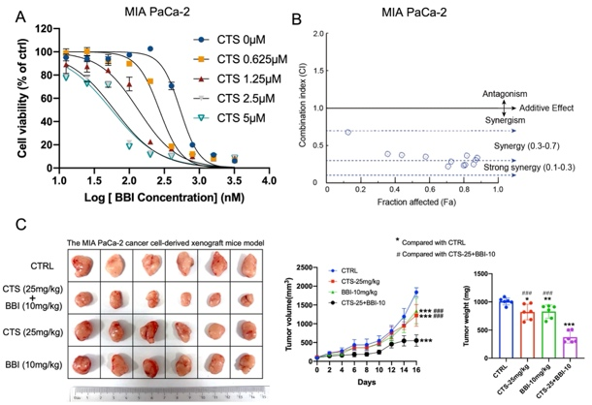
Introduction. The STAT3 inhibitor BBI608 is a potential NQO1-bioactivatable compound with promising anti-cancer potential; However, its clinical application still faces multiple challenges, including identification of optimal therapeutic regimens, and management of side effects.
Aims. This study aimed to explore a strategy to reduce the treatment dose of BBI608 while enhancing its efficacy.
Methods. The human pancreatic cancer cell lines were treated with cryptotanshinone (CTS), BBI608, or in combination, and cell viability was evaluated. The synergistic effects were evaluated by Chou-Talalay combination index (CI) method. NQO1 activity was determined by an in vitro NQO1 reaction system using recombinant human NQO1. The in vivo synergistic anti-cancer effects of CTS and BBI608 were evaluated with a MIA PaCa-2-derived xenograft mouse model.
Results. CTS and BBI608 showed synergistic cytotoxicity in human PDAC cell lines (CI＜1.0). The NQO1 activity assay revealed that CTS and BBI608, when administered individually, only modestly increased NQO1 enzymatic activity at low concentrations, whereas their co-treatment induced NQO1 enzymatic hyperactivation. Furthermore, MIA PaCa-2-derived xenograft mouse model demonstrated that co-administration of CTS and BBI608 significantly enhanced the anti-tumor efficacy compared to BBI608 monotherapy.
Discussion. CTS and BBI608 exert synergistic anti-pancreatic cancer effects both in vitro and in vivo by inducing NQO1 enzymatic hyperactivation, which provide a strategy to enhance the therapeutic efficacy of BBI608.
This study was supported by the Science and Technology Development Fund, Macau SAR (0070/2022/A2).

