**Understanding the Effects of Lower Airway Generations on Upstream Particle Deposition of Inhalation Aerosols – A Computational Modelling Study**

**Xinyu Cai1**, Hak-Kim Chan2,3, Agisilaos Kourmatzis3,4, Shaokoon Cheng1,3

School of Engineering, Faculty of Science and Engineering, Macquarie University1

Advanced Drug Delivery Group, Sydney Pharmacy School, Faculty of Medicine and Health, The University of Sydney, Sydney, New South Wales, Australia2

ASK Scientia Pty Ltd, Sydney, NSW, Australia3

School of Aerospace, Mechanical and Mechatronic Engineering, The University of Sydney, Sydney, NSW, Australia4

**Background and aims.** Computational models of the human airway have been widely used to study aerosol transport and deposition mechanisms. However, the complexity of airway geometries has varied significantly across published studies. This study aimed to evaluate how different levels of lower airway complexity affect particle deposition and airflow dynamics, with the goal of informing what may be suitably considered a high-fidelity airway model.

**Methods.** The geometry of a human lung was reconstructed from CT scans. Lung models incorporating different generations of bronchial branching were developed, and computational fluid dynamics (CFD) simulations were performed using the discrete phase model. Monodisperse aerosol particles with a diameter of 3 µm were introduced under steady state flow rates of 60 L/min and 120 L/min. Velocity profiles at various locations along the trachea were compared to assess whether lower airway complexity influences upstream flow behaviour.

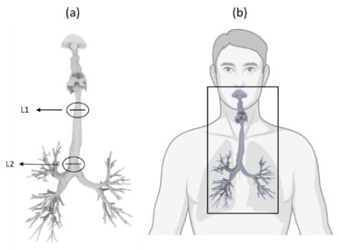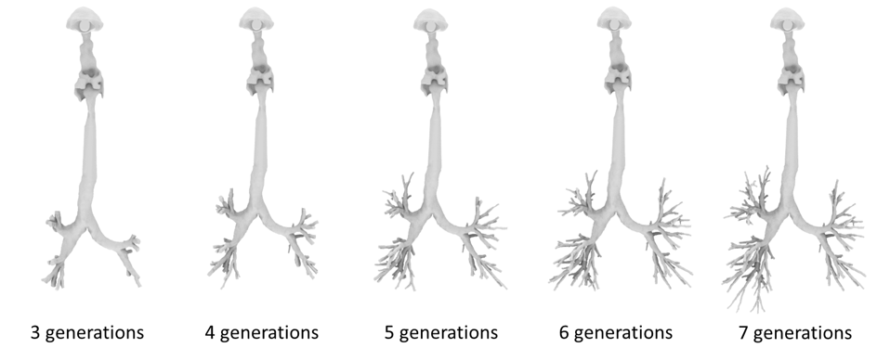

*Figure 1: (a) Models with different airway generations, and the locations of L1 and L2. (b) depicts how the model scales relative to a geometrically representative human model.*

**Results.** Figure 1(a) shows the velocity profiles at L1 and L2. While the velocity profile at L2 remains fairly consistent across all models with different lower airway generations, the velocity profile at L1 differ notably. For both flow rates, the velocity profiles appear to be similar when the models consist of 6th or 7th lower airway generations. Potential effects of velocity profiles on particle deposition in the lungs are shown in the adjacent table. Results show that the relative differences (with the simplest airway model as the baseline) in particle deposition decreases with increasing number of lower airway generations.

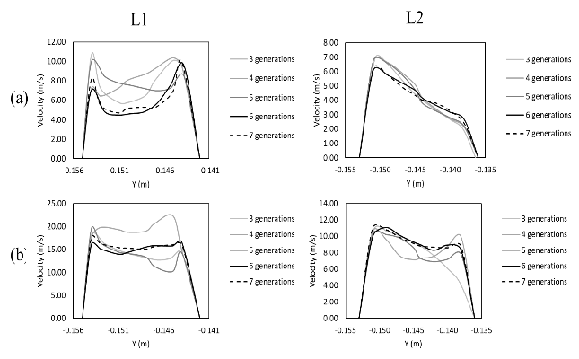

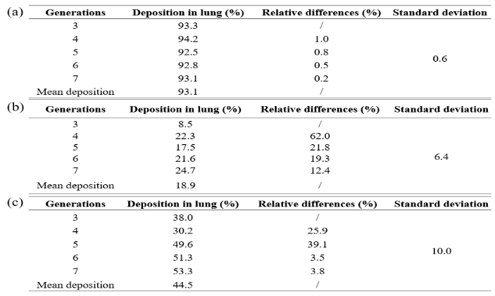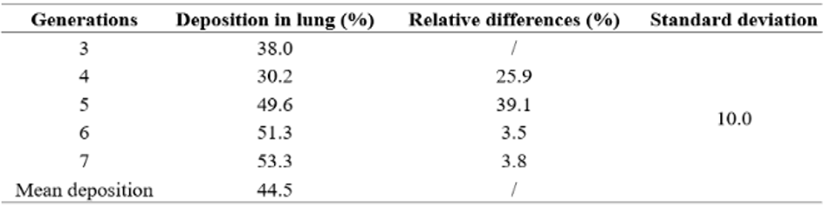

*Figure 2: Velocity profiles simulated at (a) 60 L/min, and (b) 120 L/min. Table: Lung deposition for the two different flow rate conditions (a) 60 L/min, (b) 120 L/min.*

**Conclusion/Discussion.** Results from this study show that lower airway geometry and complexity may influence aerosol transport and deposition patterns, likely through their impact on airflow dynamics. The findings suggest that models incorporating fewer than six bronchial generations may not adequately resolve the flow structures necessary for accurate deposition modelling. These results have important implications for the development of reliable in silico and experimental airway testing frameworks.