**Biomineralized Calcium Carbonate Hybrid Microcomposite for Enhanced Oral Bioavailability of Water-Insoluble Phytochemicals**

**Jung-Ki Hong1**, **Yeji Kang1**, Chan Hee Lee2, Ee Taek Hwang3 and In-Soo Yoon1

Department of Manufacturing Pharmacy, College of Pharmacy and Research Institute for Drug Development, Pusan National University1, Geumjeong-gu, Busan, South Korea;

EMBST Co., Ltd.2, Saha-gu, Busan, South Korea;

Department of Food Biotechnology, Dong-A University, Saha-gu, Busan, South Korea.

**Background and aims.** Luteolin(LUT), a poorly water-soluble natural bioactive compound, faces significant bioavailability challenges, limiting its application. This study aimed to develop a β-cyclodextrin stabilized calcium carbonate (CaCO3) microcomposite to improve the oral bioavailability of LUT.

**Methods.** A LUT-loaded CaCO3 microcomposite was fabricated via a precipitation-based biomineralization technique. Its physicochemical properties, in vitro solubility, dissolution, and in situ intestinal absorption were evaluated. Oral bioavailability was then measured through an in vivo pharmacokinetic study.

**Results.** The biomineralization technique yielded a CaCO3 microcomposite with an excellent LUT loading capacity of 40.5%. Comprehensive characterization confirmed successful encapsulation. The CaCO3 microcomposite significantly enhanced the in vitro solubility across various pH, in vitro dissolution rate, and in situ intestinal absorption of LUT. Furthermore, the in vivo pharmacokinetic study definitively showed a 4.68-fold enhancement in LUT oral bioavailability compared to pure LUT powder.

|  |  |  |  |
| --- | --- | --- | --- |
| **Parameter** | **Unit** | **Powder** | **Microcomposite** |
| AUC | ng·min/mL | 1091 ± 555 | 5106 ± 1103* |
| t1/2 | min | 77.1 ± 73.1 | 132 ± 62.8 |
| Cmax | ng/mL | 15.2 ± 12.3 | 269 ± 55.3* |
| Tmax | min | 15 (5–15) | 5 |
| Relative bioavailability | % | 100 | 468 |
| *Significantly different from the pure powder group (*p* < 0.05). | | | |

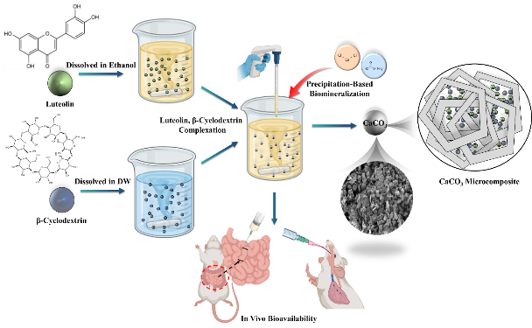

**Figure 1.** Schematic representation for the fabrication of LUT-loaded CaCO3 microcomposite and its evaluation procedures. **Table 1.** Pharmacokinetic parameters of LUT following the oral administration of pure LUT powder and LUT-loaded CaCO3 microcomposite in rats (n = 5).

**Conclusion/Discussion.** This study successfully demonstrated the use of CaCO3 microcomposite to significantly improve the oral bioavailability of poorly water-soluble bioactive compounds, particularly LUT. The impressive 4.68-fold increase in bioavailability demonstrates the enormous potential of this novel biomineralization-based approach. This work provides a promising and scalable solution to overcome solubility and absorption limitations, which could expand the therapeutic and commercial applications of various natural compounds in the nutraceutical and pharmaceutical fields.

**References:**

(1) Ambrogi, V. (2023) Pharmaceutics, 15(1), Article300

(2) Alshehrl, S., et al (2020) ACS Omega, 5(12), 6461-6471