**Optical Method for Real-time Testing of Respirable Powder Dissolution**

**Taye T. Mekonnen1**, Xinyu Cai2, Athiya Azeem3, Shaokoon Cheng2,3, Hak-Kim Chan,3,4, Agisilaos Kourmatzis1,3

School of Aerospace, Mechanical & Mechatronic Engineering, The University of Sydney1, NSW, Australia.

School of Engineering, Macquarie University2, NSW, Australia.

ASK Scientia Pty Ltd3, NSW, Australia

Sydney Pharmacy School, The University of Sydney3, NSW, Australia

**Background and Aims**. With increasing demand for pulmonary drug delivery, there is a pressing need for rapid *in vitro* tools to assess drug formulation dissolution, improving in vitro–in vivo correlation and batch testing. Existing analytical methods are slow, labor-intensive, and poorly suited for measurement in environments that mimic *in vivo* conditions1,2. This study presents a non-destructive optical approach for real-time characterization of inhalable drug powder dissolution behaviour.

**Methods.** An optical dissolution testing method was developed using a custom optical coherence tomography (OCT) probe2. This probe, integrated directly into a custom dissolution chamber, continuously tracked solution concentration by detecting changes in the refractive index of a dissolution media. To validate the system's accuracy, solutions of ethanol, water and known concentrations of mannitol powder were measured and compared against a standard refractive index detector (RID). Further measurements were conducted using powder formulations with varying particle sizes, active ingredients and excipient content, manually added to the dissolution chamber to evaluate the sensitivity of the optical sensor.

**Results.** Results showed that the developed optical dissolution testing method accurately tracked solution concentration through refractive index changes. Initial validation confirmed the system's accuracy, as refractive index measurements of known solutions showed good agreement (R2>0.9) with those obtained using a standard refractometry method (Fig. 1(a)). The system also demonstrated high sensitivity to variations in powder characteristics (e.g., particle size, active ingredient and excipient content), with distinct dissolution profiles observed across different drug powders as shown in Fig. 1(b).

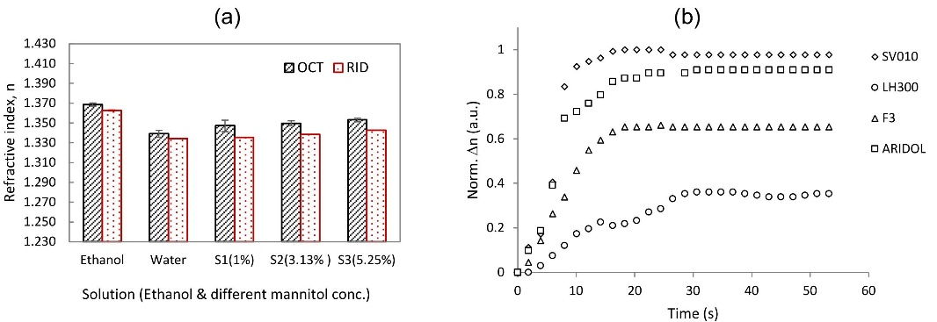

**Figure 1**. (a) Comparison of refractive index measurements between the proposed method and RID using ethanol, tap water, and three mannitol concentrations (1%, 3.13%, and 5.25% w/w). (b) Typical dissolution profiles of 40mg of lactose powders (SV010 (Dv50 = 109 µm), LH300 (Dv50 = 5 µm)), a lactose-salbutamol sulfate (SS) blend (F3: 4.5% SS, 5% LH300, 90.5% SV010), and commercial Aridol (mannitol) in 16mL tap water, which was continuously stirred magnetically during measurement.

**Conclusion/Discussion.** The OCT-based platform provides real-time, in situ insights into the dissolution behavior of inhalable drugs. Its speed, reproducibility, and capability to function in physiologically relevant environments, such as diffusion-based dissolution setups, makes it valuable for rapid batch screening and formulation optimization.

**References:**

(1) Wang, Q. et al (2006) Dissolution Technologies, 13(3), 6–13.

(2) Arora, D. et al (2010) Pharmaceutical Research, 27(5), 786–795.

(3) Mekonnen, T. et al (2024) Opt. Lasers Eng., 180, 108329.