**Development Potential of Internal Quality Control Panels for Blood Glucose Testing in Laboratories in Vietnam**

**Thuan TM Nguyen1**, Dung TV Nguyen2

Department of Biochemistry, Faculty of Pharmacy, University of Medicine and Pharmacy at Ho Chi Minh City1, Ho Chi Minh City, Viet Nam

Faculty of Medicine and Pharmacy, Tay Nguyen University2, Daklak Province, Viet Nam

**Background and aims.** Blood glucose testing plays an important role in diagnosing and monitoring the effectiveness of diabetes treatment. Infrequent quality control of testing will affect the accuracy of test results. The purpose of this study was to establish internal quality control (IQC) samples for blood glucose testing to help laboratories proactively and regularly perform IQC of tests.

**Methods.** 5 ml of whole blood was collected from 10 healthy volunteers, anticoagulated with K2EDTA, then pooled and centrifuged to separate the plasma. Half of the plasma samples were spiked with 1 M glucose to produce high glucose samples and aliquoted into sterile tubes. Each IQC panel contained plasma samples with normal and high glucose concentrations. The stability and homogeneity of IQC panels under storage conditions at -20oC and transport conditions were evaluated using Levey-Jennings chart and Westgard rules, and compared simultaneously with a commercial IQC panel. Blood glucose concentrations were measured on an Erba XL640 automated biochemical analyzer.

**Results.** The stability of IQC panels in this study was comparable to that of commercial IQC panels. The samples in IQC panels were homogeneous, stable up to 3 months at -20oC (see Figure 1) and up to 24 hours under transport conditions.

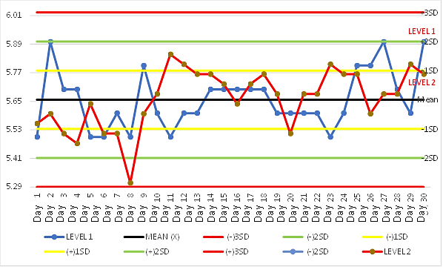

**Figure 1.** Levey-Jennings chart for glucose levels of IQC sample panels over 30 days (normal concentration-Level 1, high concentration-Level 2)

**Conclusion/Discussion.** The IQC panels in this study were in liquid form and could be used immediately without the need to reconstitute the sample into solution before use. The IQC sample for blood glucose testing was developed to be widely used to ensure the quality of blood glucose test results at laboratories in Vietnam. We greatly thank the University of Medicine and Pharmacy at Ho Chi Minh City and Buon Ma Thuot Medical Testing Center for their support in completing this study.

**References:**

(1) CLSI (2010). Procedures for the Handling and Processing of Blood specimens for Common Laboratory Tests; approved Guideline – 4th ed. CLsi document H18-a4. Wayne, Pa: Clinical and Laboratory standards institute.

(2) Gruber, L. et al (2024). Internal Quality Controls in the Medical Laboratory: A Narrative Review of the Basic Principles of an Appropriate Quality Control Plan. Diagnostics (Basel). 5;14(19):2223.

(3) Giannoli, J-M. et al (2025). Ensuring internal quality control practices in medical Laboratories: IFCC recommendations for practical applications based on ISO 15189:2022. Clinica Chimica Acta. 571: 120240