Effect of a Novel Triple Single-Pill Combination on Systolic Blood Pressure Variability
Tian Wang¹, Stephen Van Der Hoorn¹, Sonali Gnanenthiran¹, Anthony Rodgers¹, Aletta E. Schutte¹. ¹The George Institute for Global Health, Sydney, NSW, Australia

Introduction. The effect of which BP lowering therapies are most effective in reducing systolic BP variability (SBPV) remains unclear.
Aims. To evaluate the effect of a novel triple single-pill combination (SPC), Widaplik (containing telmisartan [T], amlodipine [A], and indapamide [I]), compared with placebo and dual therapies (TI, TA, AI) on SBPV.
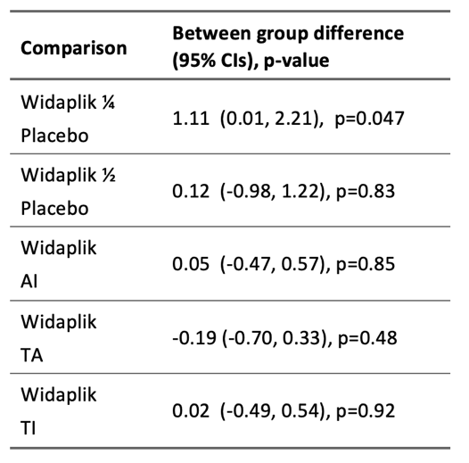
Methods. Individual patient data from two randomized controlled trials were analysed: (1) a placebo-controlled trial (PCT, n=295) investigated the efficacy of two doses of Widaplik (¼ and ½) versus placebo over 4 weeks; and (2) an active-controlled trial (ACT, n=1385) compared standard-dose Widaplik with dual therapies over 12 weeks. BPV was assessed from home BP (HBP) measurements using the coefficient of variation (CV).
Results. A total of 1584 participants (mean age: 58 years; 52% female) with ≥2 HBP readings were included. In the PCT, no difference in CV was observed between Widaplik ½ dose and placebo, but Widaplik ¼ dose showed a higher CV (+1.11, CI: 0.01, 2.21) compared with placebo at Week 4. In the ACT, no significant between-group differences were observed between Widaplik, AI, TI and TA.
Discussion. In patients with mild-to-moderate BP elevation, no significant between-group differences were observed between Widaplik ½ and placebo, or between standard-dose Widaplik and dual therapies (AI, TA, TI).

Do not change the margins, the font, size or any other setup on this template. The abstract should be left-and right-justified. Line spacing must be single. The abstract must be one A5 page only. The abstract must be typed in Calibri 10 point. Do not use bold in the abstract text, only the title should be in bold. As abstract pages may be printed in black and white only, you may consider including tables and images in greyscale. Please pay particular attention to these instructions as abstracts that do not conform will not be accepted by the editors.

The text should be as informative as possible. If you have any problems please call Expert Events on +61 7 3848 2100 or ascept-hypertensionau@expertevents.com.au

McCartney P (2001) J J 56:23-33
Starr R et al (2005) Pharmacology of FAB-4, ed Ono Y. pp 12-23, Tokyo, Abbey Road Press

