“Begin with the end in mind” in pharmacology and pharmaceutical science education.
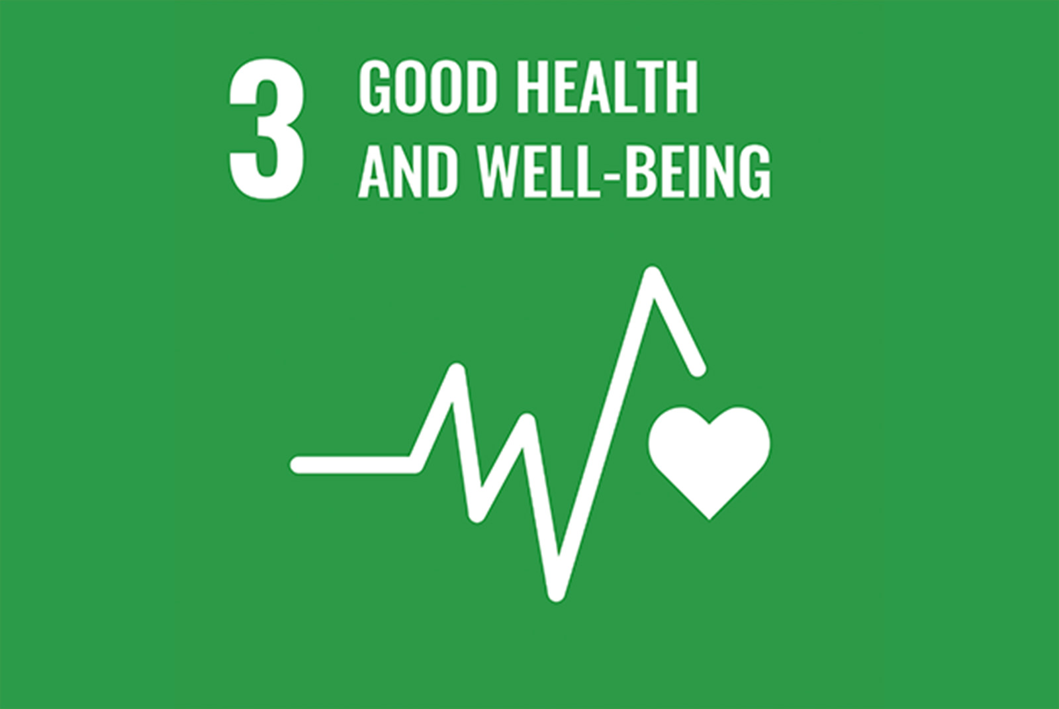
Anya Maan-Yuh Lin, College of Pharmaceutical Sciences, National Yang Ming Chiao Tung University, Hsin-Chu, Taiwan

To improve the lives of the people on earth, the United Nations proposed 17 Sustainable Development Goals (SDGs) for the period from 2015 to 2030. Among these, SDG3 aims to establish good health and well-being for all mankind. A high quality of life, especially a healthy body and mind, is expected. Because of the rapid progress of science and technology, novel therapeutics and medical devices are being developed to meet health and medical needs. Experts with pharmacology and pharmaceutical sciences are contributing their efforts to SDG3 for a better healthcare. Cultivating experts with pharmacology and pharmaceutical sciences requires liberal arts literacy, updated knowledge in pharmacology and pharmaceutical sciences, as well as internship and leadership training. Assessments include academic activities, hand-on courses and continuing education since the lifelong learning is critical for career success. New knowledge, methodologies, technologies, and regulatory requirements are constantly evolving and should be updated for the career competencies, including precision health/medicine, regenerative medicine, artificial intelligence and machine learning, digital health technologies and regulatory sciences. For the sustainability, gendered innovation and greener environments, such as carbon reduction and green chemistry should be taken into consideration for the pharmacology and pharmaceutical sciences. In conclusion, cross-disciplinary education is the foundation for a successful career in pharmacology and pharmaceutical sciences. Experts in pharmacology and pharmaceutical sciences should be initiative and creative and always at the forefront of scientific innovation for global health of humanity.

