Temperature-directed morphology transformation method to produce well-defined complex multifunctional polymer particles

Valentin A. Bobrin, Sung-Po R. Chen, Zhongfan Jia, Michael J. Monteiro

The Australian Institute for Bioengineering and Nanotechnology, The University of Queensland, St. Lucia, Brisbane, Queensland 4072, Australia

Polymer nanoparticles have attracted considerable attention due to their fascinating features such as stimuli-responsive properties or variability of chemical functionality. Despite the great progress made in structural control and functionalization of multicompartment nanostructures, challenges still remain to produce multicompartment particles rapidly at a high polymer weight fraction, with a stable morphology over time and multiple functionalities to perform several functions. Herein, we demonstrated a rapid and reproducible novel method to generate well-defined multifunctional polymer nanoparticles with complex geometries, such as polymeric tadpoles¹. This type of nanoparticles might bring considerable enrichments to the fields of nanotechnology due to a unique geometric shape with two compartments: the head and the tail. It was found that the temperature-directed morphology transformation (TDMT) method offered a remarkable platform for the rapid synthesis of chemically multifunctional polymeric tadpoles at a high polymer weight fraction (10 wt. %). The key feature of our system is the ease of control of not only types of functional groups but also their stoichiometry independently for the head and the tail of tadpoles. Moreover, we demonstrated that the TDMT method provides a powerful self-assembly strategy to produce multi-arm asymmetric nanoparticles² as well as uniform symmetric and asymmetric polymer nanostructures³.

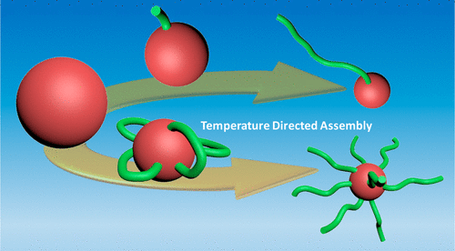

Scheme 1. Temperature-Directed Self-Assembly of Tadpole to Multi-Arm Polymer Nanostructures Directly in Water
V. Bobrin, M. Monteiro, J. Am. Chem. Soc. 2015, 137, 15652-15655
² V. Bobrin, S. Chen, Z. Jia, M. Monteiro, ACS Macro Lett. 2017, 6, 1047-1051
³ V. Bobrin, S. Chen, Z. Jia, M. Monteiro, Biomacromolecules 2018, 19, 4703-470

Dr. Valentin A. Bobrin
Phone: +61733464162,
E-mail: v.bobrin@uq.edu.au

