Longitudinal comparative pharmacodynamic modeling of novel targeted biologics in generalised myasthenia gravis
Sayantan S Roy¹, B M Padhy¹, A Srinivasan¹, A Wasnik², Dept of Pharmacol, AIIMS¹, Bhubaneswar, OD, India; Dept of CM&FM, AIIMS², Bibinagar, TG, India.

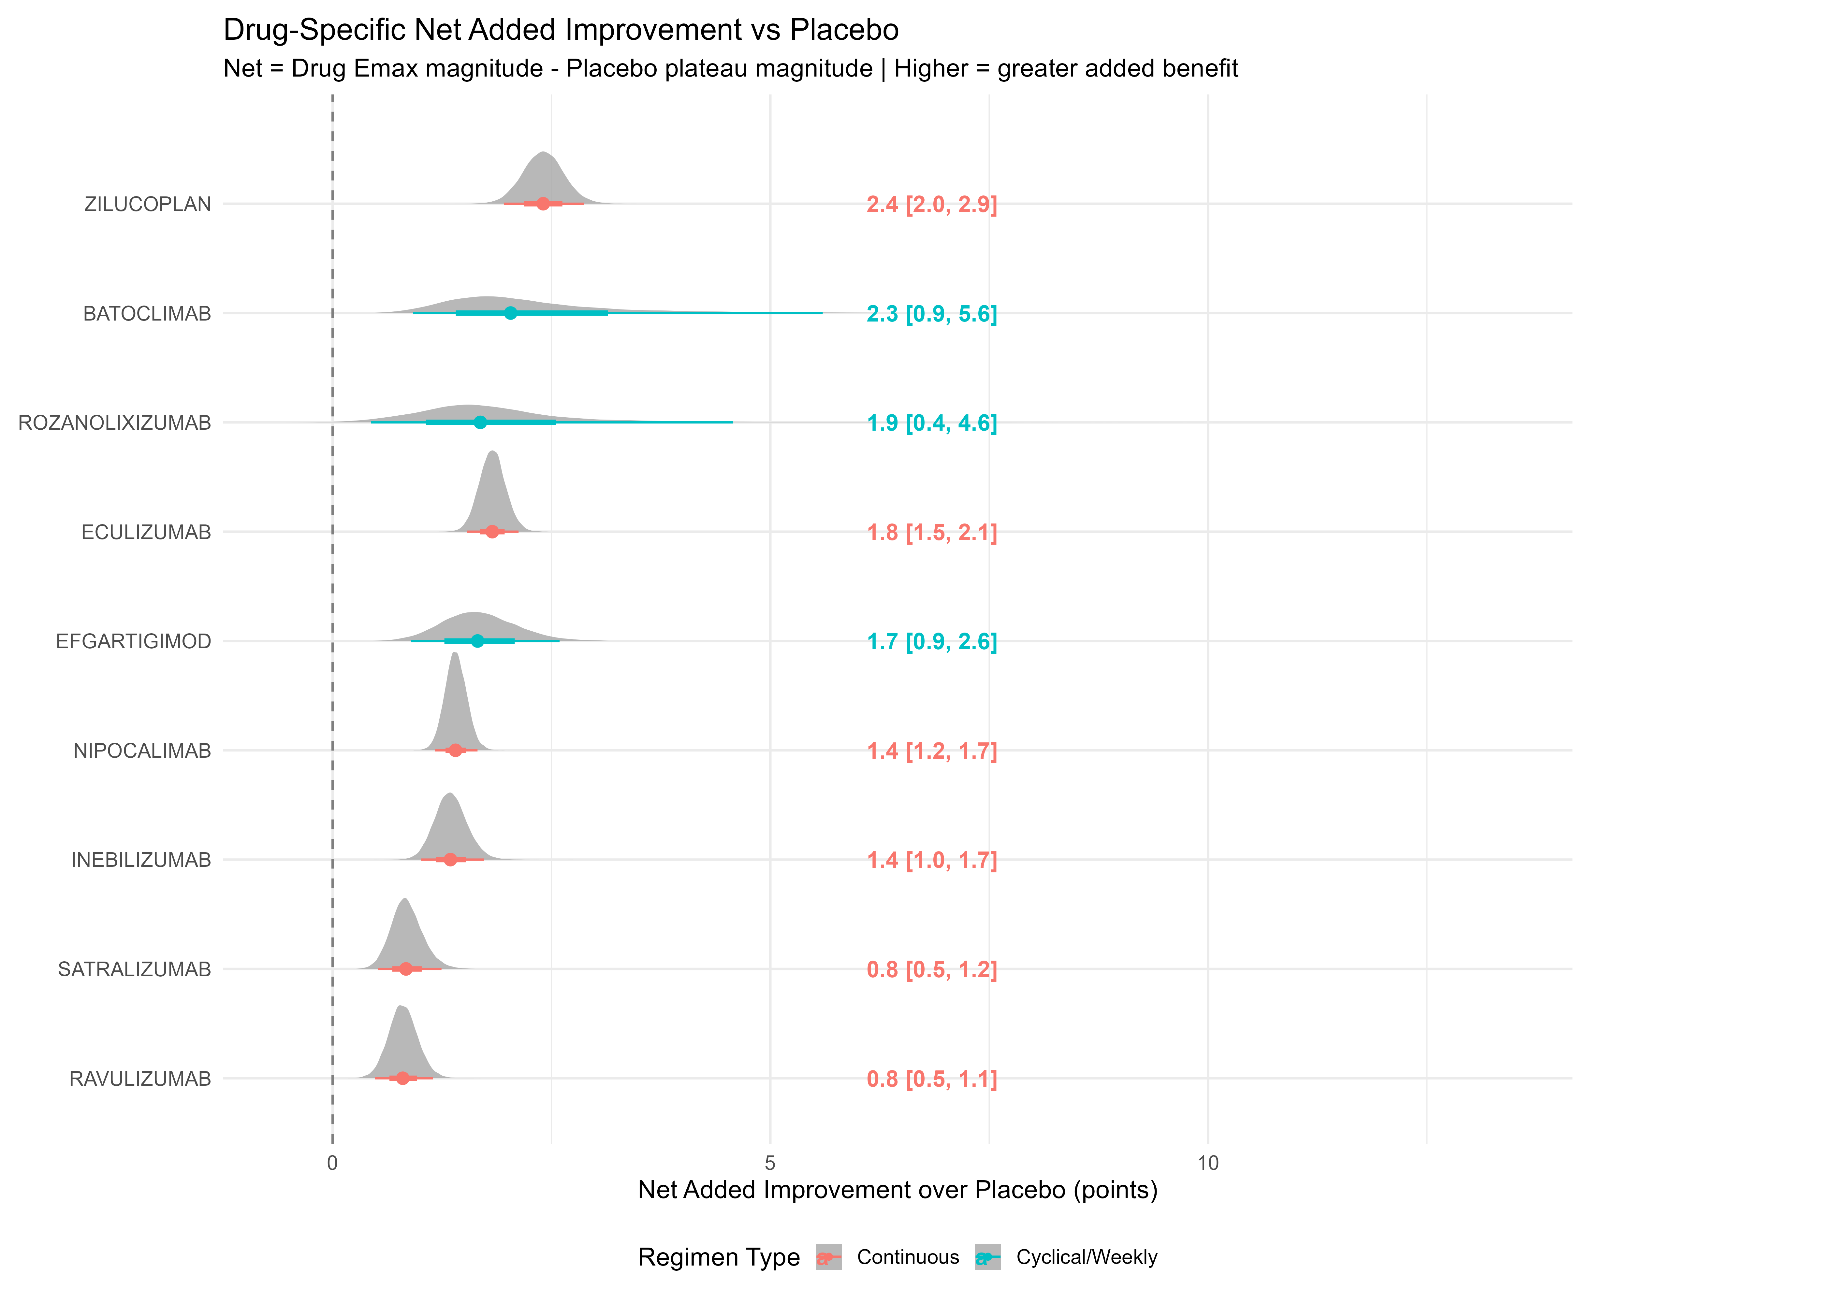Introduction. Generalised myasthenia gravis (gMG) is a chronic autoimmune disorder. Targeted biologics demonstrate efficacy through diverse mechanisms and dosing regimens. Traditional meta-analyses overlook longitudinal trajectories, dose accumulation, and regimen heterogeneity.
Aims. To develop nonlinear mixed-effects models quantifying the time-dose-response relationship of MG-ADL (Myasthenia Gravis-Activities of Daily Living) and QMG (Quantitative myasthenia gravis) score change, and estimate PD and derived PD summary measures, week-26 predictions, and ranking net benefit vs placebo.
Methods. PubMed, Embase, Cochrane Central and Clinicaltrials.gov were searched. Summary-level data with multiple time points per treatment arm were extracted from phase III randomised, double-blind, placebo-controlled trials. Distinct Emax-onset models were fitted for continuous and cyclical/weekly regimens. Inverse variance weighting and Bayesian estimation were applied. Models were validated. It was registered with PROSPERO (ID: CRD420261288549).
Results. Zilucoplan demonstrated the highest Emax (4.8 [4.3, 5.2]) and net added improvement versus placebo (2.4 [2.0, 2.9]) for MG-ADL, while Batoclimab demonstrated the highest values for QMG (Emax 5.7 [4.4, 8.6]; net added improvement 3.9 [2.6, 6.8]), indicating superior long-term efficacy. Efgartigimod achieved the fastest meaningful benefit, with a time-to-change of 2.2 weeks for MG-ADL and 1.6 weeks for QMG. Zilucoplan also had the greatest cumulative benefit (area under the effect curve) of 112 for MG-ADL at week 26, while efgartigimod had 121 for QMG.
Discussion. Zilucoplan showed the greatest long-term efficacy and cumulative benefit, while efgartigimod achieved the fastest meaningful improvement. Our results align with prior network meta-analyses, but our dose-time-exposure modeling approach quantifies the parameters, making the findings robust and interpretable for future guidelines.

Ma Y et al (2024) CNS Drugs 38:93-104
Zhong H et al (2024) Front Neurol 15:1479685

