Role of SIT1 (SLC6A20) in transporting proline and neurotransmitters
Huanyu Z. Li¹, Ashley C. W. Pike¹, Irina Lotsaris², Gamma Chi¹, Jesper S. Hansen¹, Sarah C. Lee³, Karin E. J. Rödström¹, Simon R. Bushell¹, David Speedman¹, Adam Evans¹, Dong Wang¹, Didi He¹, Leela Shrestha¹, Chady Nasrallah¹, Nicola A. Burgess-Brown¹, Robert J. Vandenberg², Timothy R. Dafforn³ , Elisabeth P. Carpenter¹ & David B. Sauer¹. Centre for Medicines Discovery, University of Oxford¹, Oxford, United Kingdom; School of Medical Sciences, University of Sydney², Sydney, NSW, Australia; School of Biosciences, University of Birmingham², Birmingham, United Kingdom.
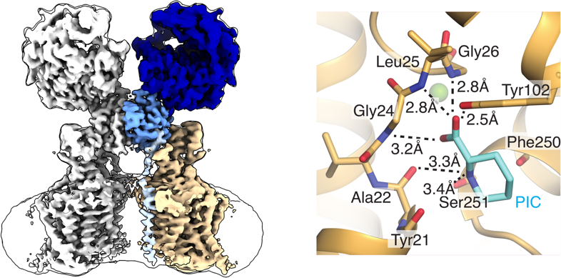
Introduction. Proline is widely known as the only proteogenic amino acid with a secondary amine. In addition to its crucial role in protein structure, the secondary amino acid modulates neurotransmission and regulates the kinetics of signalling proteins.
Aims. To understand the role of SIT1 in modulating neurotransmission, we aimed to describe its mechanisms to selectively bind and transport amino acids. Further, we wanted to understand the structural and functional consequences of SIT1’s complex with the COVID-19 viral receptor ACE2.
Methods. To understand the structural basis of proline import, we solved the structure of the proline transporter SIT1 in complex with the COVID-19 viral receptor ACE2 by cryo-electron microscopy, biochemical binding studies, and electrophysiology.
Results. The structure of pipecolate-bound SIT1 reveals the specific sequence requirements for proline transport in the SLC6 family and how this protein excludes amino acids with extended side chains.
Discussion. By comparing apo and substrate-bound SIT1 states, we identified the structural changes that link substrate release and opening of the cytoplasmic gate and explain how a missense mutation in the transporter causes iminoglycinuria. Further, these results shed light on SIT1’s transport of proline and glycine in the brain and thereby its effects on neurotransmission.

