Discovery of selective TRPC3 inhibitors as a potential therapy for CNS diseases
Wei Li¹. Department of Pharmaceutical Sciences, College of Pharmacy, University of Tennessee Health Science Center¹, Memphis, TN, USA

Introduction. Transient receptor potential canonical 3 (TRPC3) protein belongs to the TRP family of nonselective cation channels. Perturbations in the expression of TRPC3 are associated with a plethora of pathophysiological conditions responsible for disorders of the cardiovascular, immune, and central nervous systems. Pharmacologically targeting TRPC3 in animal models has demonstrated great efficacy in treating diseases, including cancers, neurological disorders, and cardiovascular diseases. The development of small-molecule TRPC3 modulators with high safety, sufficient brain penetration, and acceptable drug-like profiles remains in progress, and the success will potentially lead to new therapies for several diseases, especially for CNS diseases.
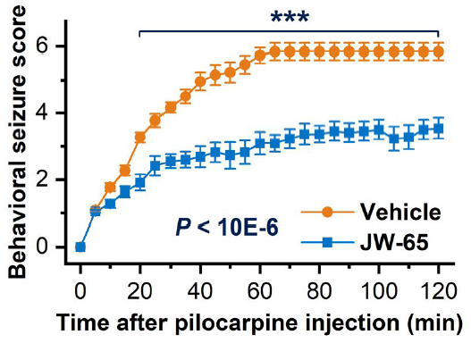
A representative selective TRPC3 inhibitor, JW-65, shows significant suppression of epilepsy in a mouse model.
Aims. We aim to develop highly TRPC3-selective, brain-penetrable, and potent TRPC3 inhibitors that could be further developed as a new therapy for CNS diseases, focusing on epilepsy as the first indication.
Methods. Using comprehensive medicinal chemistry and rational drug discovery approaches, we have discovered a new set of highly selective TRPC3 inhibitors.
Results. Our data shows that these selective TRPC3 inhibitors can adequately penetrate the blood-brain barrier and show promising preclinical efficacy in multiple mouse models of epilepsy.
Discussion. Further characterization and development of these TRPC3 inhibitors to generate a potential clinical candidate could significantly benefit not only patients with epilepsy, but also patients with other CNS diseases, such as Alzheimer's disease or cardiovascular diseases, where TRPC3 overexpression/overactivation is involved.

