Factors influencing the uptake of doxorubicin into BT-20 triple-negative breast carcinoma spheroids
Cara de Moura-Cunningham¹, June Serem², Ross Anderson³, Keith Ncube¹, Werner Cordier¹. Dept of Pharmacology¹, Dept of Anatomy², Dept of Physiology³, Univ of Pretoria, Pretoria, South Africa.

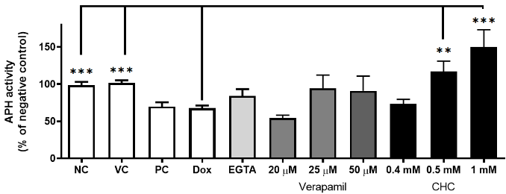
Introduction. Doxorubicin, a commonly used antineoplastic drug against triple-negative breast cancer relies on cellular transport, ionisation, and membrane permeability for uptake into solid tumours (Rivankar 2014). Given rising chemoresistance, further elaboration for contributing factors to uptake is needed.
Aims. To determine doxorubicin’s cytotoxicity in combination with agents altering membrane integrity (P-gp transporter function (verapamil) and pH (α-cyano-4-hydroxycinnamate [CHC]) in BT-20 triple-negative breast carcinoma spheroids.
Methods. The 72-hour cytotoxic effects of Day 4 spheroids treated with doxorubicin, EGTA, verapamil, or CHC were assessed with planimetry, and acid phosphatase activity. Combinations were evaluated by fluorescence microscopy, while western blotting profiled E-cadherin and overall cadherin expression.
Results. Doxorubicin (10 µM) reduced spheroid volume by 27.5% and viability by 39.9% (n=10, P<0.0001), while EGTA (2 mM) disrupted spheroid integrity. Doxorubicin with 1.5 mM EGTA increased viability by 16%, verapamil at 25–50 µM increased viability by 25%, and CHC increased viability by 49% (n=10, P<0.001) at 0.5 mM and 82% at 1 mM (n=11, P<0.0002). Microscopy revealed an increase in doxorubicin accumulation in spheroid cores after combinational treatment. Western blotting showed differential cadherin profiles between monolayer and spheroid cultures.
Discussion. Doxorubicin treatment may upregulate E-cadherin expression through reactive oxygen species generation (Na et al 2021). Retained protons, resulting from CHC treatment, could limit nuclear uptake of the drug through ionisation. These findings suggest that altering these factors may alter the response towards doxorubicin, however, further investigation is needed to ascertain to what degree this can be modulated.

Rivankar S (2014) J. Cancer Res. Ther. 10(4):853-8
Na et al (2021) Biochem Biophys Res Commun. 567:131-137

