Employing recombinant venom proteins in combination with a synthetic hydrogel to control bleeding after major trauma

*Amanda W. KijasA, Sidara EngelhardtA, Zhao Jeff WangA, Jan LaukoA, Petri TurunenA, Lambro JohnsonB, Paul MasciB, Kong-Nan ZhaoB, John de JerseyB, Martin LavinC and Alan E. RowanA.*

AAustralian Institute for Bioengineering and Nanotechnology, The University of Queensland, Brisbane, Australia; BTranslational Research Institute, The University of Queensland, Brisbane, Australia; CUniversity of Queensland Centre for Clinical Research, The University of Queensland, Brisbane, Australia.

**Significance**: Trauma is a leading cause of death and disability worldwide with an estimated 40 % of these deaths due to hemorrhage (bleeding) and in a military setting this rate is as high as 90 % even when the injuries were considered potentially survivable (1,2). Death due to hemorrhage is a preventable death.

**Background:** We have designed a novel haemostatic agent, to control bleeding, for use in the pre-medical facility phase of care that employs a potent Procoagulant Snake Venom Protein (PSVP) to activate the formation of the natural endogenous fibrin biopolymer hydrogel network. This is used in combination with a synthetic polyisocyanopeptide hydrogel scaffold to provide a robust composite biosynthetic network resistant to endogenous degradation pathways. This synthetic hydrogel scaffold is biocompatible and thermo-responsive, enabling easy application to irregular wound sites and has mechanical properties that reflect that of biopolymers such as fibrin (3,4). This novel agent also incorporates a recombinant Anti-fibrinolytic Snake Venom Protein (ASVP) to stop fibrin breakdown.

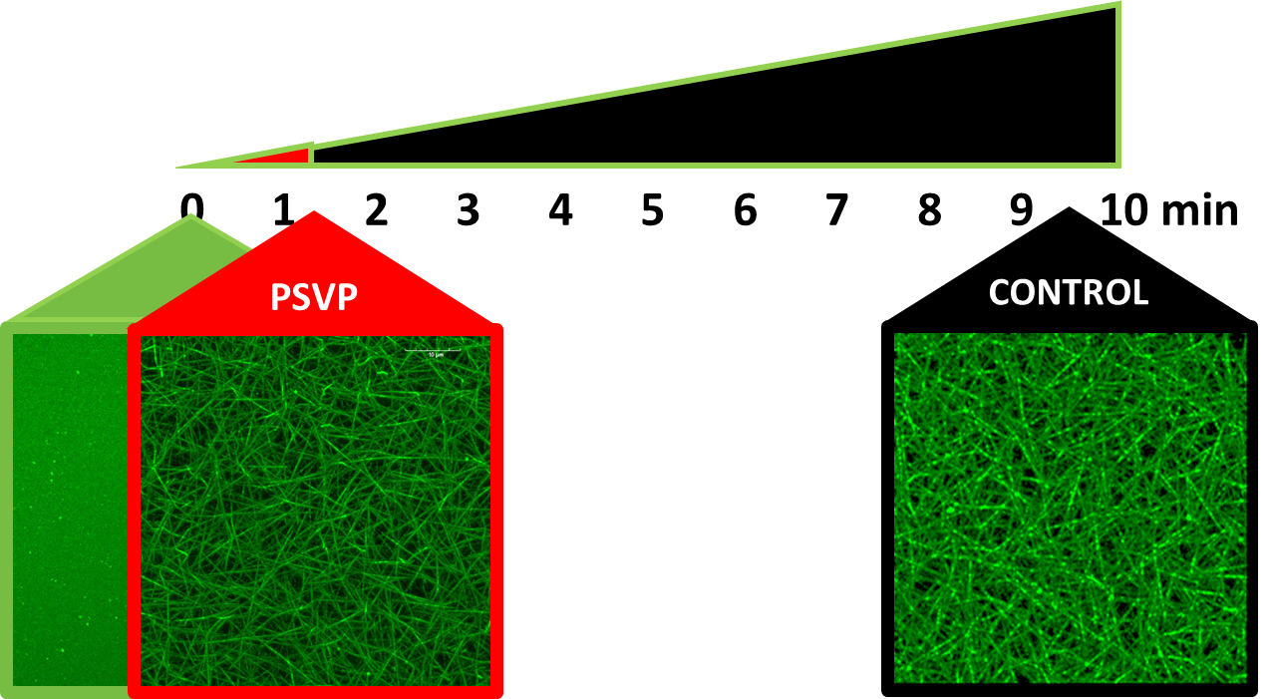**Results:** Using blood clotting assays, we observe that 1 nM recombinant procoagulant snake venom protein, PSVP, rapidly initiates fibrin clot formation (Figure 1). The incorporation of the recombinant anti-fibrinolytic, ASVP, provides resistance of these blood clots to the endogenous blood clot breakdown factor, plasmin. These clots are further reinforced in the presence of the synthetic polyisocyanopeptide hydrogel. By combining these bioactive components (PSVP and ASVP) with the synthetic hydrogel, we hypothesize that we will be able to rapidly and stably control bleeding.

**Figure 1.** Timing of fibrin network formation

(Alexa 488 labelled fibers) in the presence of

the procoagulant snake venom protein, PSVP

(red boxed fibrin network) as compared to the

control condition (black boxed fibrin network).

**References:**

1. Peden and Sharma. (2002). The injury chart book: a graphical overview of the global burden of injuries. World Health Organization, Geneva.
2. Current Tactical Combat Casualty Care (2017). TC3 ed. US Government.
3. Kouwer et al. (2013). Responsive biomimetic networks from polyisocyanopeptide hydrogels. Nature, 493, 651-655.
4. Das et al. (2016). Stress-stiffening-mediated stem-cell commitment switch in soft responsive hydrogels. Nat. Mater., 15, 318-325.