Linking 5-FU therapeutic drug monitoring with dihydropyrimidine dehydrogenase (DPD) phenotype and genotype.
Lauren Clarke¹, Rui Zhang¹, Rhonda Maguire¹, Conchita Boyder¹, David A Joyce^{1, 2}, Sam Salman^{1, 2, 3}
¹Clinical Biochemistry and Pharmacology Department, PathWest, Nedlands, WA, Australia;²Medical School, UWA, Crawley, WA, Australia;³Curtin Medical School, Curtin University, Bentley, WA, Australia

Introduction. Therapeutic drug monitoring (TDM) assists in refining doses to optimise efficacy and minimise toxicity after treatment has commenced. The risk of severe toxicity or even death with some drugs, however, warrants prospective testing of metabolic clearance before first dose administration. Thiopurine drugs, such as azathioprine, and fluoropyrimidine drugs, such as 5-fluorouracil (5-FU), are particular examples of drugs that require estimation of metabolic clearance before initiation of therapy. Dose selection for thiopurines at our centre has long rested on the three therapeutic pillars of phenotype, genotype and TDM. More recently, we have established DPD phenotyping and 5-FU TDM to extend the three-pillar concept to fluoropyrimidine drugs, where dosing guidance has typically been heavily influenced by genotype alone.
Aims. Review the utilisation and results of a DPD phenotype and 5-FU TDM service after implementation, to supplement DPYD genotyping alone, to optimise fluoropyrimidine dosing.
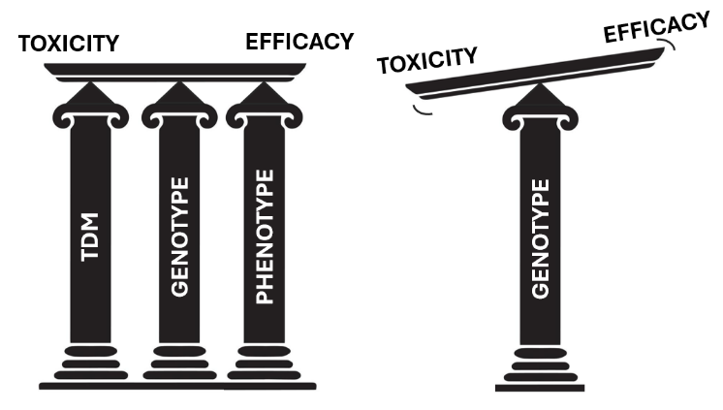
Methods. DPD phenotype, determined from pretherapeutic plasma uracil level (LC/MS), 5-FU TDM (LC/MS) and genotyping.
Results. Results of phenotype, 5-FU TDM, and DPYD genotype (where available), accrued during the first 6 months of the service are summarised and examined for distributions and correlations between the three sources of dosage guidance.
Discussion. The results of this audit inform ongoing local practice and offer a first evaluation of the three-pillar dosing approach for fluoropyrimidines in practice in Australia.

