**Electrochemical Nitrogen Reduction Reaction on Two-Dimensional Antimonene Nanosheets for Ammonia Synthesis**

*Munkhjargal Bat-Erdene,A Guangrui Xu,B,C Munkhbayar Batmunkh,A,D Abdulaziz S. R. Bati,A Md J. Nine,E Dusan Losic,E Yu Chen,C Tianyi Ma,B Joseph G. Shapter,A\**

*E-mail:* [*m.baterdene@uq.net.au*](mailto:m.baterdene@uq.net.au)*;* [*j.shapter@uq.edu.au*](mailto:j.shapter@uq.edu.au)

**A** Australian Institute for Bioengineering and Nanotechnology, The University of Queensland, Brisbane, QLD 4072, Australia

**B** Discipline of Chemistry, School of Environmental and Life Sciences, The University of Newcastle (UON), Callaghan, NSW 2308, Australia

**C** Key Laboratory of Macromolecular Science of Shaanxi Province, Key Laboratory of Applied Surface and Colloid Chemistry (Ministry of Education), Shaanxi Key Laboratory for Advanced Energy Devices, School of Materials Science and Engineering, Shaanxi Normal University, Xi’an 710062, PR China

**D** Centre for Clean Environment and Energy, Griffith University, Gold Coast, QLD 4222, Australia

**E** School of Chemical Engineering, The University of Adelaide, Adelaide, SA 5005, Australia

Designing efficient and stable catalysts for the nitrogen (N2) reduction reaction (NRR) based ammonia (NH3) synthesis has been the subject of intense investigation. Herein, we prepared ultrathin two-dimensional (2D) antimonene nanosheets using a combination of ball milling and sonication-based liquid exfoliation method and used them as noble-metal-free electrocatalyst for NRR for the first time. Our 2D antimonene nanosheets without any supporting catalyst exhibit an impressive activity and excellent stability for efficient electrocatalytic conversion of N2 to NH3. At a potential of +0.05 V versus the reversible hydrogen electrode (RHE), a high NH3 yield of ⁓294.9 μg h-1 mg-1CAT) and Faradaic efficiency (FE) of ⁓25.5 % is achieved under ambient conditions using the 2D antimonene. This work opens up a new avenue towards the development of 2D electrocatalysts.

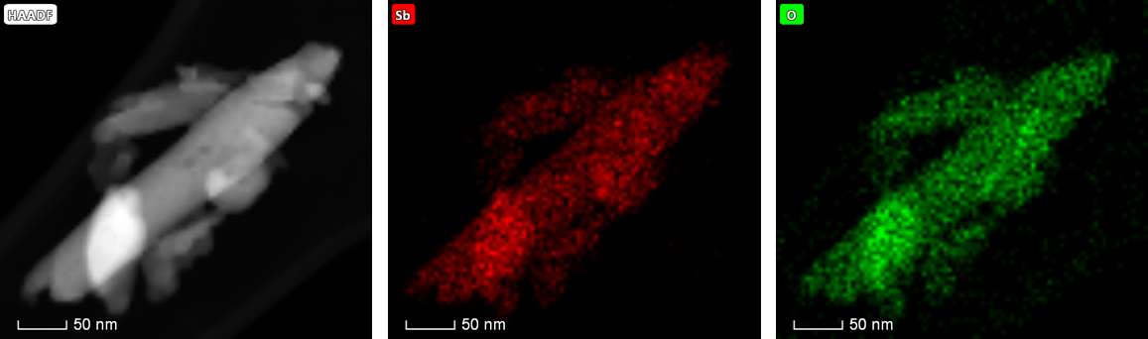

Figure. HAADF and elemental (Sb and O) mapping of antimonene nanosheets.

**References**

1. W. Qiu, X. Y. Xie, J. Qiu, W. H. Fang, R. Liang, X. Ren, X. Ji, G. Cui, A. M. Asiri, G. Cui, B. Tang, X. Sun. *Nat Commun*., **2018**, 9, 3485.
2. L. Zhang, L. X. Ding, G. F. Chen, X. Yang, H. Wang. *Angew. Int. Chem. Ed*., **2019**, 58, 2612-2616.
3. L. Zhang, X. Ji, X. Ren, Y. Ma, X. Shi, Z. Tian, A. M. Asir, L. Chen, B. Tang, X. Sun*. Adv Mater*., 2018, 30, 1800191.