**The EV-phage Biobots – unraveling natural synergies of extracellular vesicles and bacteriophage as a multifunctional therapeutic agent for infected skin wounds**

Jiaqi Liu.

**Background and aims.** Both bacteriophages (phages) and extracellular vesicles (EVs) have unique potential in treating infected wounds. Phage shows promising results in eliminating harmful bacteria and penetrating biofilm. On the other hand, EVs have demonstrated potential to reduce oxidative stress, activate the immune system and promote tissue regeneration. EVs have also demonstrated that they can simultaneously activate multiple cells, including stem, progenitor, and immune cells. This means that EVs stimulate the body’s immune system, working collectively with phage to overcome infection and inflammation. However, to achieve superior antimicrobial and anti-inflammatory activity, phage and EVs must be conjugated. Taken together, these findings led to establishing a technology to combine EVs and phage and for the first time to bioengineer new multifunctional biomaterial – the EV-phage biobots ­– with pre-defined molecular composition to achieve effective antimicrobial activity and promote tissue repair simultaneously.

**Methods.**

* Select and isolate EVs, propagate bacteriophage (phage) and conjugate them into biobot formulation.
* Characterise the physiochemical properties of EVs and biobots, which can help us understand cell viability after exposure to biobots/EVs/polymer/phage, also investigate MTD (maximum tolerated dose) and dose adjustment.
* Investigate the potential therapeutic effect of biobots on infected wounds.

**Results.** Overall, biobots are non-cytotoxic and effective in promoting wound healing (multifunctional). Depending on the biobot type they showed some differences in biological functionality which was also specific to different cells. Both biobots showed the capacity to enhance healing by improving recellularization or improving cell migration capacity.

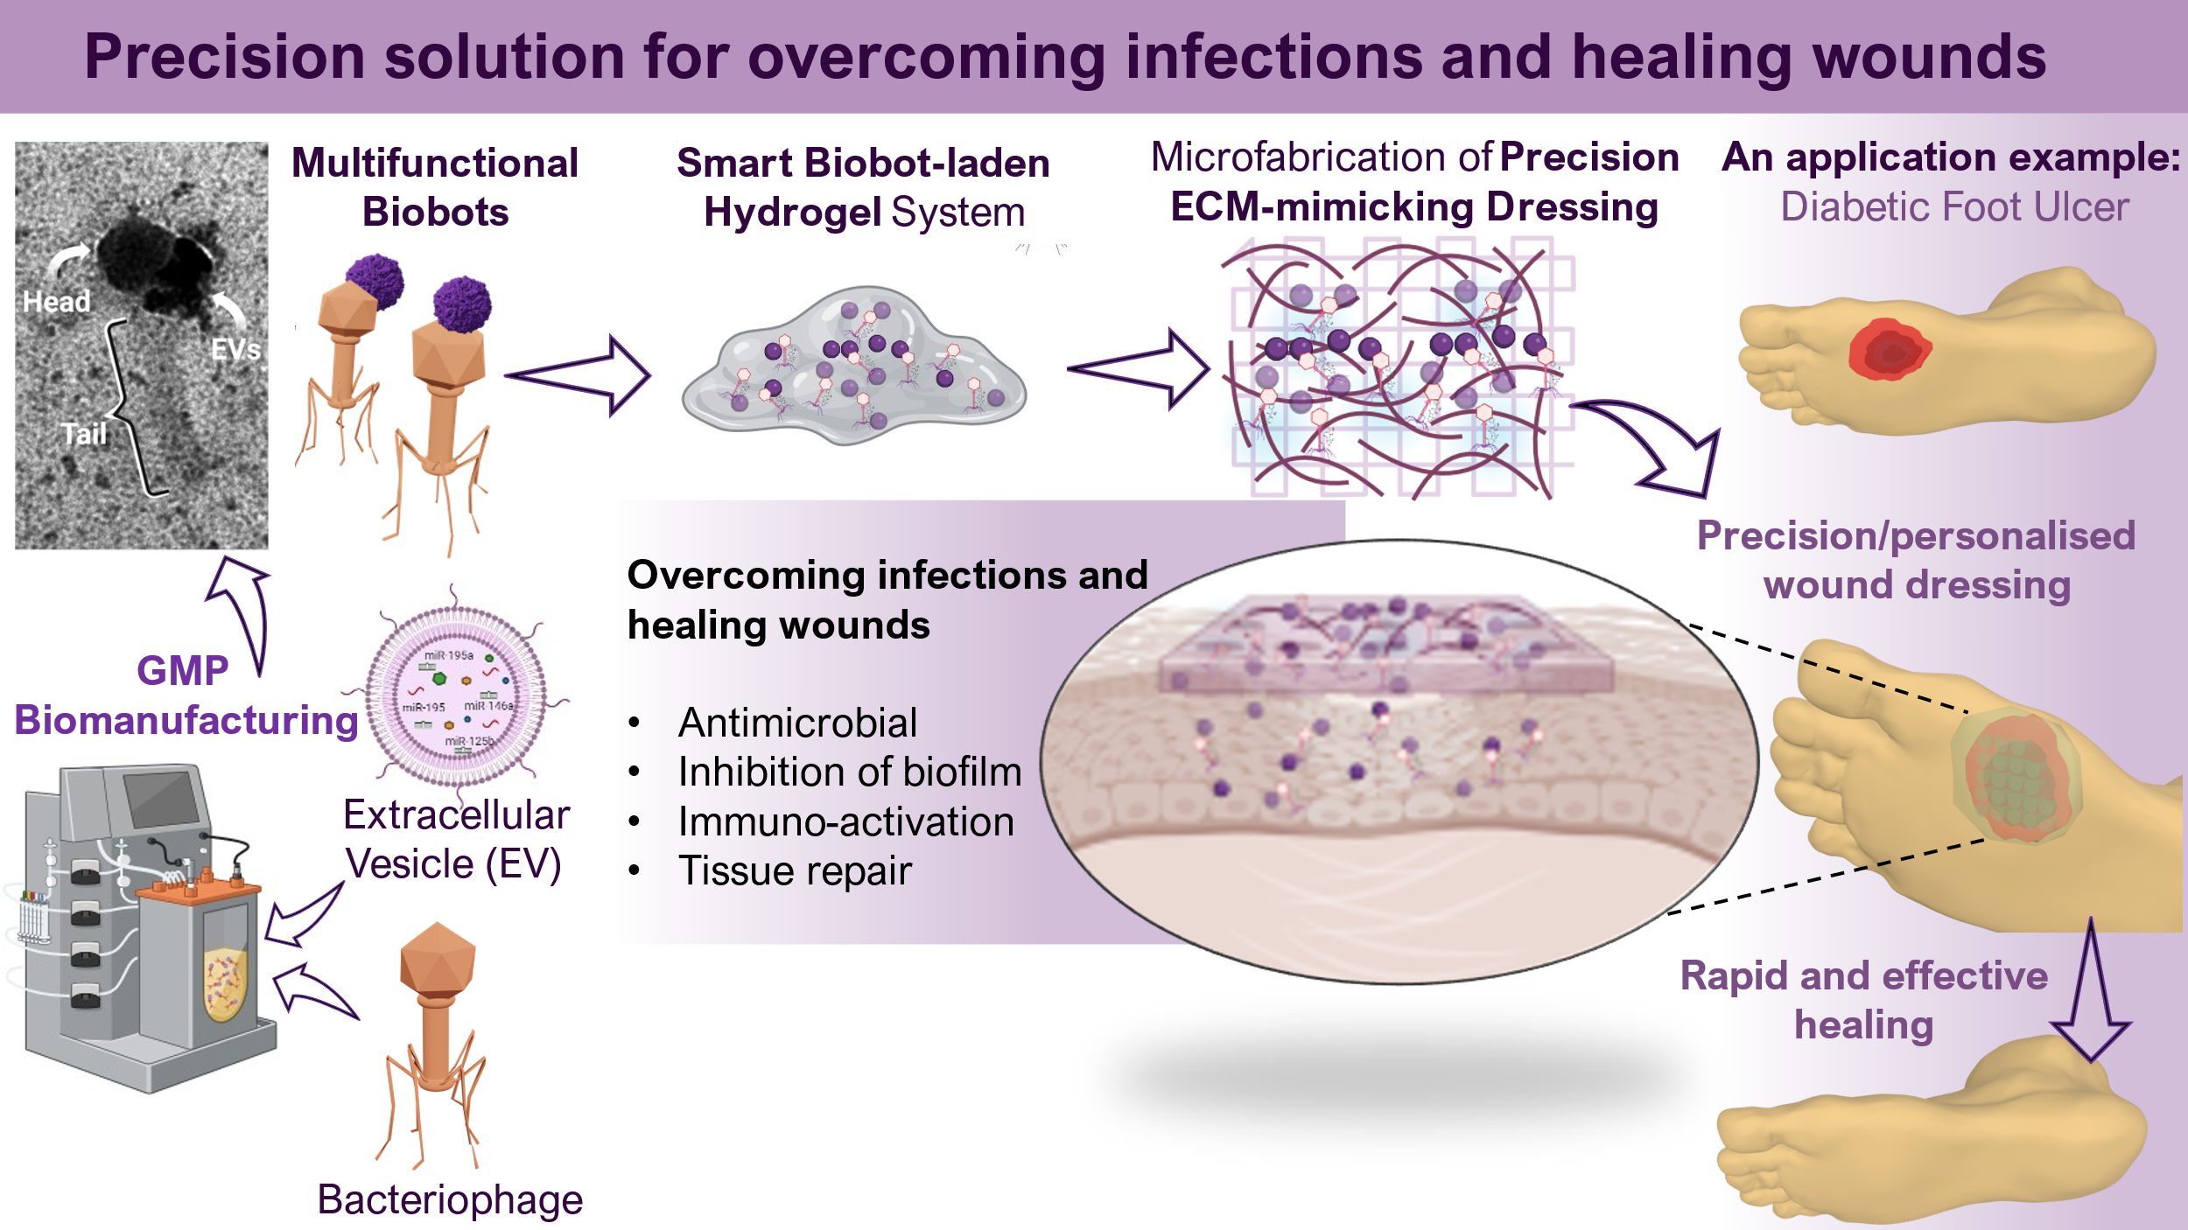

**Figure 1.** Biobot concept development

**Conclusion/Discussion.** In conclusion, both biobots types we presented are safe and provide unique multifunctionally in reducing bacterial growth and enhancing wound healing. Advantageously, the phage-EV conjugate provides targeted dual activity since EVs can target specific tissues or organs as well. The phage component of the phage-EV conjugate is capable of preventing and/or treating bacterial infection at a damaged tissue site, thereby reducing impaired tissue repair associated with infection. The EV component of the phage-EV conjugate promotes tissue repair. Administering an EV using a phage-based carrier can allow for potentially controlled, site-specific delivery of the EV, thereby achieving therapeutic local concentration at the site of the damaged tissue and/or infection.