**CXCL17 as a novel MRGPRX2 agonist: importance of cellular context**

Jie Ding, Graham A Mackay. Dept of Biochemistry & Pharmacology, University of Melbourne1, Parkville, VIC, Australia.

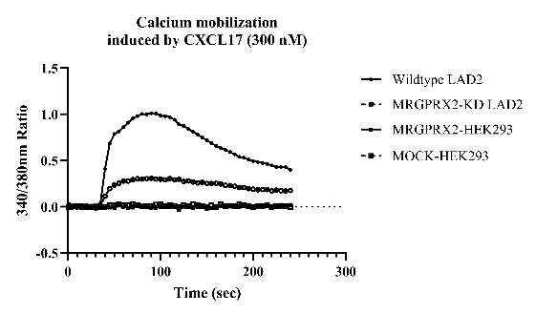**Introduction.** The Mas-related G protein-coupled receptor X2 (MRGPRX2) is selectively expressed on mast cells and is activated by diverse polycationic peptides. We have identified that CXCL17 acts as a novel endogenous agonist of MRGPRX2 in mast cell activation and demonstrated the clinical implication of CXCL17-MRGPRX2/MC pathway in psoriatic skin1. However, the MRGPRX2 signalosome that leads to effective mast cell degranulation is not well understood.

**Aims**. To further characterise CXCL17-induced, MRGPRX2-mediated cellular activation mechanisms.

**Methods**. We used the human mast cell line LAD2 that natively expresses MRGPRX2, MRGPRX2 knockdown LAD2 cells generated by CRISPR-Cas9 technology and HEK293 cell line expressing human MRGPRX2. Calcium mobilization in response to CXCL17 and other MRGPRX2 agonists was measured using fura-2. CXCL17 binding to MRGPRX2, and downstream G protein-activation were determined using NanoBRET™ assays. Immunoprecipitation of LAD2 and MRGPRX2-expressing HEK293 cell lysates were conducted with an anti-MRGPRX2 antibody coupled to Dynabeads® with pulldown proteins identified by mass spectrometry.

**Results.** Compared to LAD2 mast cells, CXCL17 does not trigger Ca2+ mobilisation and Gq activation in MRGPRX2-transfected HEK293 cells (Fig 1). In immunoprecipitation studies, 76 proteins were identified within MRGPRX2 pulldowns in LAD2 mast cells with 40 proteins being uniquely expressed compared to MRGPRX2-expressing HEK293 cells. In addition, 19 proteins were increased upon MRGPRX2 activation in LAD2 mast cells.

**Discussion.** Our results show that MRGPRX2 activation by CXCL17 is cell context specific, suggesting that additional cellular components, perhaps unique to the mast cell, are necessary for productive receptor activation. The identified proteins immunoprecipitated with MRGPRX2 in LAD2 cells likely contribute to this mechanism and may serve as targets for novel mast cell inhibiting drugs.

*1Ding J et al (2024) Allergy doi:10.1111/all.16036.*