Research and Innovation to Optimise Medication Regimens in Older Adults with Heart Failure
Parag Goyal MD MSc, Program for the Care and Study of the Aging Heart, Department of Medicine, Weill Cornell Medicine, New York, NY, USA
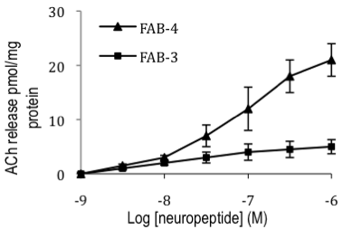
Introduction. Polypharmacy (and complex medication regimens) is nearly universal among older adults with heart failure.
Aims. To evaluate the value of N-of-1 trials as an innovative strategy to promote patient-centered medication optimization (and deprescribing).
Methods. We conducted serial N-of-1 trials among older adults with heart failure to understand whether N-of-1 trials are feasible and acceptable, improve shared-decision making parameters, and promote deprescribing. We also examined the influence of beta-blocker use on multiple patient-reported outcomes.
Results. We found that N-of-1 trials are feasible and acceptable, improve shared-decision making parameters, and promote deprescribing. We also found that most patient-reported outcomes were either unchanged or improved with deprescribing beta-blockers (specifically among those who did not have a strong clinical indication for beta-blocker).
Discussion. These findings indicate that N-of-1 trials may be leveraged as a patient-centered strategy to medication optimization among older adults with heart failure, and can promote deprescribing among those without a clinical indication for beta-blocker.

