**Recombinant spider silk films and hydrogels with intrinsic bacteriostatic and fungistatic properties**

*Gregor LangA,B, Sushma KumariB, Elise DeSimoneB, Christian SpenglerC, Vanessa T. TrossmannB, Susanne LückerD, Martina HudelE, Karin JacobsC, Norbert KrämerD and Thomas ScheibelB*

ABiopolymer Processing Group, Faculty of Engineering Science, University of Bayreuth, Bayreuth, Germany*;* BChair of Biomaterials, Faculty of Engineering Science, University of Bayreuth, Bayreuth, Germany; CDepartment of Experimental Physics, Saarland University, Germany; DDepartment of Paediatric Dentistry, Medical Center Gießen and Marburg, Gießen, Germany; EInstitute of Medical Microbiology, Justus-Liebig University Gießen, Gießen, Germany

**Introduction.**

Pathogenic microbial contaminations on the surface of medical products and the associated risk of infection are a severe problem especially in the public health care sector. Microbial colonization and subsequent biofilm formation are highly problematic, as biofilms are much more difficult to eradicate than isolated microbes. Furthermore, antimicrobial resistant strains are increasing at an alarming rate due to the overuse of antimicrobial agents. Consequently, microbial biofilm generation and nosocomial infection during conventional medical therapy have significantly increased mortality and healthcare costs worldwide. Since one critical step in biofilm formation is the initial adherence of pathogenic microbes onto a material’s surface, inhibiting microbial attachment is a reasonable approach to develop material surfaces resistant to biofilm formation. There are two main approaches for inhibiting surface attachment, referred to as either active or passive resistance. While passively resistant surfaces utilize super hydrophilic or hydrophobic polymers, zwitterionic and other synthetic polymers, actively resistant ones include contact killing materials such as cationic polymers, amphiphilic polymers, antimicrobial peptides and polymeric/ composite materials loaded with antimicrobial agents. Although these approaches can combat microbial infection by inhibiting mechanisms of persistence and adaptation, several drawbacks exist such as instability under physiological conditions, cytotoxicity to mammalian cells, inflammatory responses, a narrow antimicrobial spectrum, and implication for transmitting multidrug resistance. Furthermore, antimicrobial activity has been mostly investigated in terms of its effectiveness against bacteria, although fungal infections also contribute significantly to patient morbidity and mortality. Moreover, fungal infections can readily form polymicrobial biofilms with enhanced resistance to antifungal drugs, further limiting therapeutic options. Therefore, efficient mitigation of microbial infection associated with both bacteria and fungi is required for the future development of broad range multifunctional material coatings.

**Materials and Methods.**

In this work, a novel passive approach was developed, originating from the basic observation, that some silk materials display high resistance against microbial degradation. We systematically investigated the bacteriostatic and fungistatic properties of a well-established recombinant spider silk protein system in comparison to regenerated *B. mori* fibroin and polycaprolactone, a commonly used biopolymer. Therefore, different recombinantly produced spider silk proteins based on the consensus sequences of *Araneus diadematus* dragline silk proteins (fibroin 3 and 4) were processed into 2D-patterned films and 3D-hydrogels. These materials were exposed to pathogenic bacteria (*S. mutans, S. aureus, E. coli*) and fungi (*C. albicans, P. pastoris*) as well as to mammalian cells (BALB/3T3 fibroblasts). Smooth and structured films were produced from the different materials and incubated with different microbes for SEM analysis of biofilm formation. For quantitative analysis, fluorescence measurements were applied, and an AFM study was performed measuring the adhesive forces of methicillin-resistant *S. aureus* on different material surfaces. Regarding the potential use of silk hydrogels as bio-inks for biofabrication, we applied an in vitro co-culture model of microorganisms and BALB/3T3 fibroblasts to analyse the bio-selective adhesion properties of the silk materials.

**Results and Discussion.**

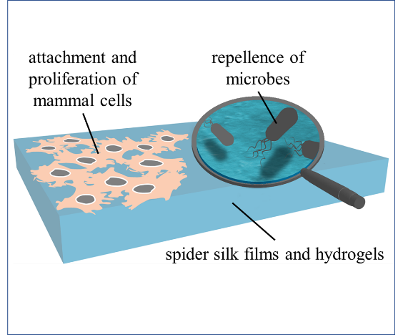Strikingly, we discovered that films and hydrogels made of recombinantly produced spider silk proteins inhibit attachment and proliferation of *S. mutans, S. aureus*, *E. coli*, *C. albicans and P. pastoris*. AFM-measurement of the adhesive forces of methicillin-resistant *S. aureus* on recombinant silk surfaces substantiated this microbial repellant property. A in-vitro co-culture model of microorganisms and BALB/3T3 fibroblasts seeded on recombinant spider silk protein-based materials elicited remarkable bacteriostatic and fungistatic properties, without killing microbes upon contact and with no apparent influence on the viability of mammalian cells. Biotechnological variations of our recombinant proteins (molecular weight, charge, amino acid sequence) and the respective results give reason to hypothesize that the underlying mechanism might be attributed to the size and distribution of beta sheet crystals resulting in anti-fouling silk nanostructures.

**Conclusion.**

Altogether, recombinant spider silk proteins represent an excellent prospect for the development of a new generation of bio-selective microbial-resistant biomaterials. Particularly in the field of biofabrication, these properties can be of interest to avoid contaminations e.g. in the tissue maturing process and subsequent implantation of cell-loaded constructs.

**Acknowledgements**

G.L. and S.K. contributed equally to this work. The authors thank Dr. Hendrik Bargel for SEM imaging. This project has been funded by the DFG SFB 840 TP A8.