**Enhancing Data Security Resilience in** **AI-Driven Digital Transformation: Exploring Industry Challenges and Solutions Through ALCOA+ Principles**

**Mikael Ham Sembiring1,** Fahrul Nizar Novagusda1.

Faculty of Military Pharmacy, Republic of Indonesia Defense University1, Sentul, Bogor, Indonesia

**Background:** The Medicines and Healthcare Products Regulatory Agency (MHRA) defines data integrity as the maintenance of accuracy, consistency, and completeness of data over time. Recently, "artificial intelligence" has become prevalent across industries, education, culture, and technology, denoting systems that mimic human intelligence and critical thinking using computers and related technologies. **Objective:** This article examines the construction of a robust artificial intelligence (AI) system and the incorporation of ALCOA+ principles for data validation, with a specific focus on enhancing data certainty and security.

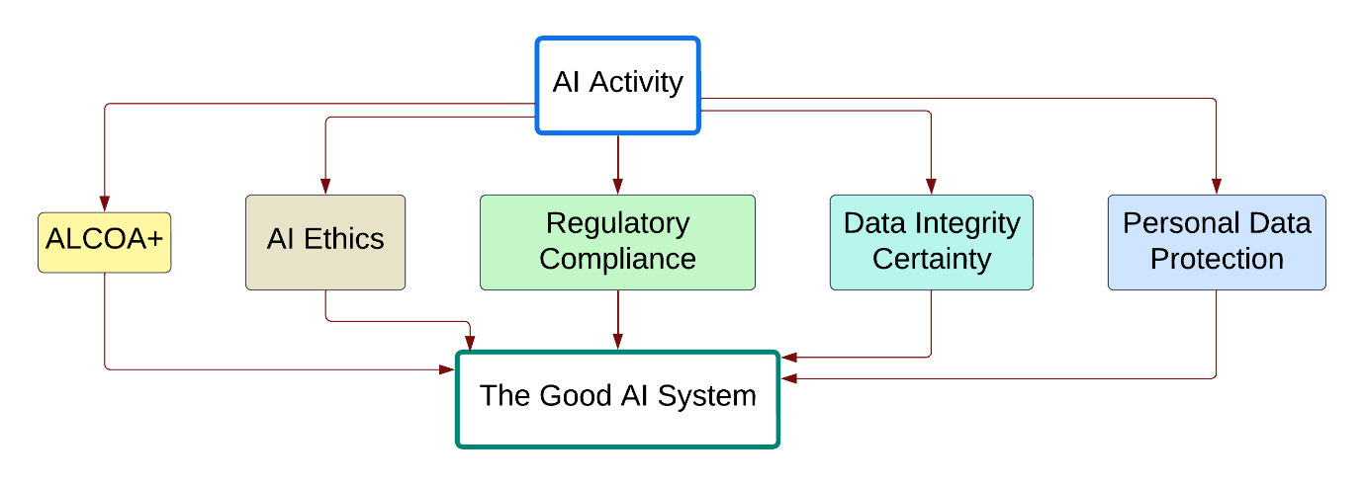

**Figure 1**. The principles of ALCOA+ (Attributable, Legible, Contemporaneous, Original, Accurate, Complete, Consistent, Enduring, Available), alongside considerations of AI ethics, regulatory compliance, data integrity certainty, and personal data protection, exert a significant impact on the field of artificial intelligence.

**Methods:** This study was carried out through a comprehensive review of various Scopus-indexed literature over the past decade. **Results and Discussion:** AI has been widely applied in Manufacturing System Optimization, involving organizing production systems, including machines, robots, conveyors, and related operations like maintenance and material handling. Moreover, it's used for Process Monitoring, Diagnostics, and Prognostics in medicine, as well as supervision and regulation in industries. Yet, it's not immune to shortcomings, which could result in system biases and jeopardize data security.

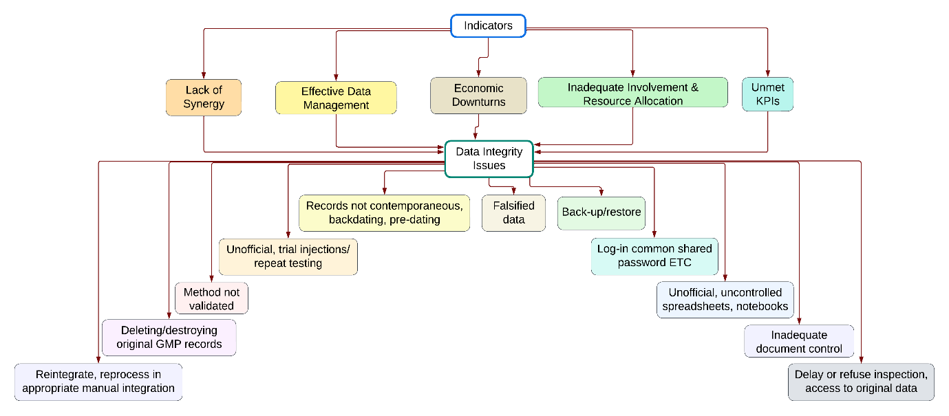

**Figure 2.** Indicators encompassing a lack of synergy and effective data management, economic downturns, inadequate involvement and resource allocation, as well as unmet key performance indicators (KPIs), can give rise to data integrity issues.

**Conclusion:** This article explores the creation of a robust AI system, implementing ALCOA+ for data validation in AI-Driven Digital Transformation to improve data certainty and security in industries. It involves systematically recording AI system activities, ensuring database validity, sustaining data recording practices, regularly updating records, ensuring authenticity and completeness, and facilitating data accessibility for review and audits. As AI integration in education advances, there's a crucial need for oversight to maintain data integrity in these systems.

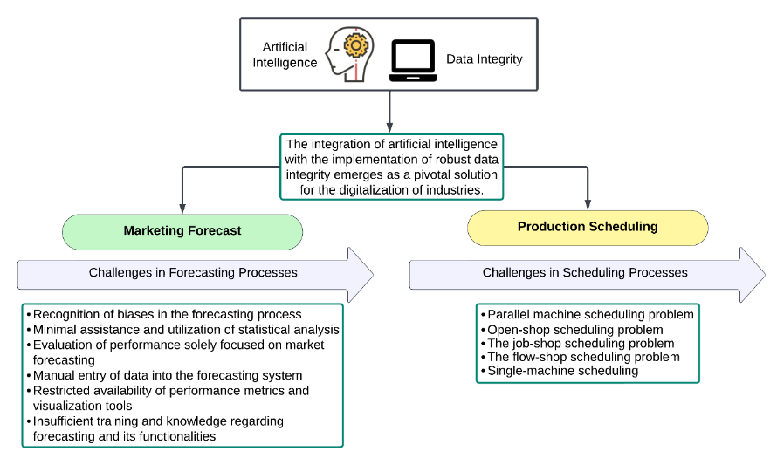

**Figure 3.** The integration of artificial intelligence with the establishment of robust data integrity emerges as a crucial solution for the digitization of industries.

**References**

1. Pralesha sahoo, & Kamaraj R. (2020). Review of Data Integrity in Pharmaceutical Industry. *International Journal of Research in Pharmaceutical Sciences*, *11*((SPL 4), 1323–1328. Retrieved from <https://ijrps.com/home/article/view/2131>
2. Singh, S., Punjabi, N., & Shah, D. (2023). IMPORTANCE OF DATA INTEGRITY IN PHARMACEUTICAL INDUSTRY. EPRA International Journal of Economics, Business and Management Studies (EBMS), 10(2), 100-106. https://doi.org/10.36713/epra12492
3. ARIFA, I., & MUSTARICHIE, R. (2020). Peneran Data Integrity di Industri Farmasi. Farmaka, 18(2), 79-88.
4. Charoo, N. A., Khan, M. A., & Rahman, Z. (2023). Data integrity issues in pharmaceutical industry: Common observations, challenges and mitigations strategies. International journal of pharmaceutics, 631, 122503. https://doi.org/10.1016/j.ijpharm.2022.122503