Inflammation-Responsive Delivery of Atorvastatin via Macrophage Membrane-Coated Solid Lipid Nanoparticles for Atherosclerosis Therapy
Bao Anh Nguyen¹, Ngoc Ha Phuong Nguyen¹, Namrah Khan¹, Jeong-Sook Park¹.
College of Pharmacy, Chungam National University¹, Daejeon, Republic of Korea.

Background and aims. Atorvastatin (ATV) clinical application for atherosclerosis treatment is hindered by low bioavailability, rapid systemic clearance, and limited plaque-targeting capacity [1]. In this study, we developed a biomimetic nanocarrier system-macrophage membrane-coated solid lipid nanoparticles (ATV-MMSLNs) to enhance the therapeutic efficacy of ATV.

Methods. Solid lipid nanoparticles (SLNs) were prepared by High-pressure Homogenization technique, followed by coating with macrophage membranes (MMs) via sonication and extrusion methods to create ATV-MMSLNs [2]. In vitro drug release studies were conducted to assess release kinetics. Western blot analysis was used to confirm membrane coating. Cellular uptake was evaluated in both non-activated and LPS-activated macrophages. The cytoprotective effect of ATV-MMSLNs under inflammatory conditions was assessed using cell viability assays in LPS-treated macrophages.

Results. ATV-MMSLNs exhibited a sustained release profile in vitro (Figure 1C). Western blot confirmed the retention of key membrane proteins CD36 and CD47, indicating successful coating (Figure 1B and D). Cellular uptake studies showed minimal internalization by non-activated macrophages, suggesting effective immune evasion. In contrast, LPS-activated macrophages demonstrated moderately enhanced uptake of ATV-MMSLNs, indicating inflammation-responsive behavior. Furthermore, cell viability assays revealed that ATV-MMSLNs improved survival of LPS-treated macrophages, suggesting a cytoprotective effect.

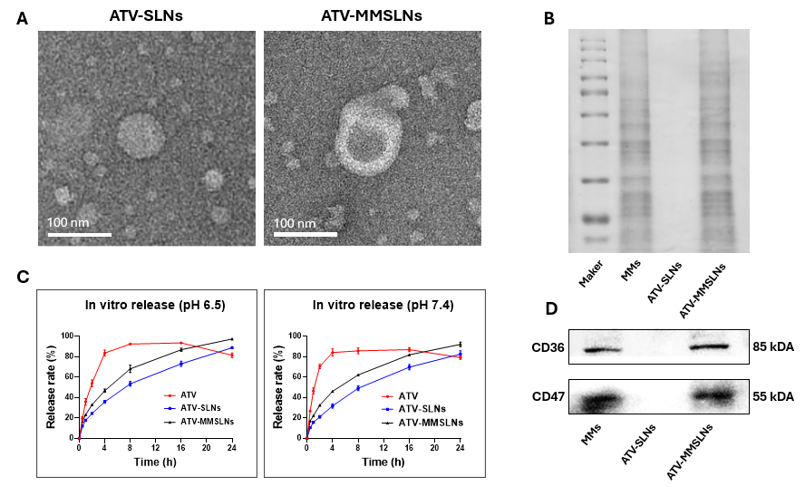

Figure 1. (A) Representative TEM image. Scale bar: 100nm. (B) Coomassie brilliant blue analysis. (C) In vitro drug release. Data are shown as mean ± SD (n = 3). (D) Western blotting images.

Conclusion/Discussion. The developed ATV-MMSLNs effectively combine sustained release, immune evasion, and moderate inflammation-targeting capacity. These findings support the potential of this biomimetic nanoplatform as a promising strategy for the treatment of atherosclerosis.

References.
(1) M. Sharma, I. Mehta (2019). Surface stabilized atorvastatin nanocrystals with improved bioavailability, safety and antihyperlipidemic potential. Sci Rep 9, 16105.
(2) H. Lu, J. Wang, et al (2024). Engineered Macrophage Membrane‐Coated S100A9‐siRNA for Ameliorating Myocardial Ischemia‐Reperfusion Injury. Adv. Sci 11, 2403542.

