Australian polypharmacy trends by sex: A descriptive population-based study (2013-2023)
Georgie Lee¹, Christopher Etherton-Beer², Julie A Pasco³, Osvaldo P. Almeida⁴, Erin Kelty⁵, Frank Sanfilippo⁵, Amy Page¹. Sch. Allied Health, UWA¹, Perth, WA, Aus; WACHA, UWA², Perth, WA, Aus; Sch. Med, Deakin Univ³, Geelong, VIC, Aus; Med Sch., UWA⁴, Perth, WA, Aus; Sch. Pop & Global Health, UWA⁵, Perth, Aus.
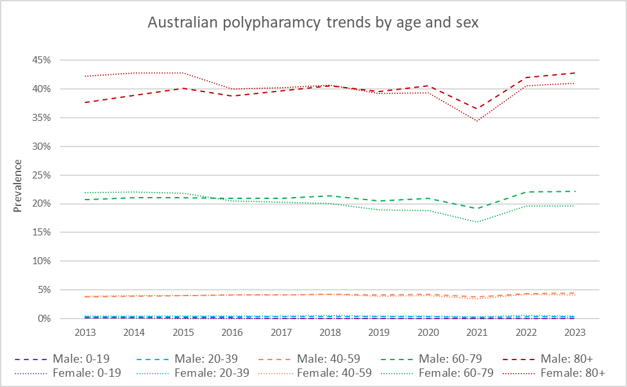
Introduction. Polypharmacy, the concurrent use of multiple medicines, is often considered an indicator of potentially suboptimal regimens. Trends research shows varying rates of growth and decline in polypharmacy across age groups; however, less is known about sex-specific patterns.
Aims. To describe polypharmacy trends stratified by sex and age in the Australian population.
Methods. We estimated annual polypharmacy prevalence using a nationally representative 10% random sample of Australian patients eligible for medicines subsidised by the Pharmaceutical Benefits Scheme (PBS). PBS-listed medicines dispensed between January 1, 2013 – December 31, 2023, were considered. Polypharmacy was defined as receiving ≥5 regularly dispensed medicines. Australian estimated residential population was used as the denominator to calculate polypharmacy prevalence by year, stratified by age and sex. Tests of proportions measured group differences.
Results. Between 2013 and 2023, Australian polypharmacy prevalence rose from 6.1% to 6.9%. In 2013, rates were higher among females, relative to males in middle age (3.9% vs 3.8%, p <.001), early older (22% vs 20.7%, p <.001) and later older age (42.8% vs 41%, p <.001). More rapid increases among males saw their prevalence surpass that of their female counterparts by 2023, among adults in middle (4.5% vs 4.1%, p <.001), early older (22.2% vs 19.6%, p <.001) and later older age (42.8% vs 41%, p <.001). The 2021 rate decline was present across age and sex strata.
Discussion. Over the last decade, disproportionate polypharmacy growth was observed among males. While females had higher rates initially, by 2023, prevalence was greater among males from middle age and up. The prevalence dip in 2021 was consistent across the population and was likely pandemic related. Further investigation into the medicines implicated in sex-specific trends may be beneficial for future deprescribing initiatives.

