Adverse Effect and Oral Chemotherapy Drug Interaction in a Yogyakarta Hospital, Indonesia

Fita Rahmawati¹, Ivon Saubaki^{,2}. Departement of Pharmacology and Clinical Pharmacy, Universitas Gadjah Mada¹, Yogyakarta, Indonesia; Master of Clinical Pharmacy , Universitas Gadjah Mada², Yogyakarta, Indonesia.

Introduction. The use of oral anticancer treatments has become a prevalent and integral component of contemporary cancer treatment ¹. The oral anticancer agents are susceptible to drug interactions and adverse effects²
Aims. This study aimed to identify the oral chemotherapy commonly used in cancer treatment, identified adverse effects and to identify potential interactions with other medications and foods.
Methods. The research type was an observational cross-sectional study. Data were collected from 105 cases of adult cancer patients in a tertiary hospital in Yogyakarta, Indonesia, from July to August 2025. Potential drug interactions are identified using UpToDate references. An adverse drug reaction was identified based on an interview with the patient. The analysis used is a simple distribution that describes the profile drug interaction and adverse drug reaction.
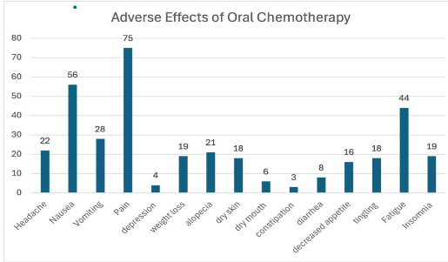
Results. The study’s findings that the oral chemotherapy mostly
prescribed included anastrazole, ⁠tamoxifen, ⁠methotrexate, ⁠capecitabin,
and ⁠exemestane. The adverse effects experienced by patients mostly
nausea and vomiting, fatique, dry mount and alopecia. The drug interactions
was identified in 10 patients, categorised as D and C.
Discussion. The adverse effects were generally manageable. Potential drug
interactions indicate the necessity for therapeutic monitoring and, in certain
cases, alternative treatment³. The use of oral chemotherapy is generally well
tolerated. In practice, close monitoring and multidisciplinary collaboration are very important.
References
- O’Neill VJ et al (2002). Br J Cancer, 87:933–937.
- Lohr LK et al (2023). J Adv Pract Oncol. 14(5):419-43.
- Jacobs et al (2019). JNCC.org. 17(3): 221-228.

