Investigation of 3,4-Dimethoxycinnamic acid as a Novel Therapeutic Agent for Rheumatoid Arthritis
Shan-Chi Liu*^{,1}. ¹Institute of Biomedical Sciences, Mackay Medical University, New Taipei City 252005, Taiwan

Introduction. Rheumatoid arthritis (RA) is a chronic autoimmune disease characterized by inflammatory infiltration of joints, causing synovial hyperplasia, cartilage damage, and bone erosion. Synovial fibroblasts and chondrocytes secrete pro-inflammatory cytokines, such as IL-1β, IL-6, and IL-8, disrupting bone homeostasis. Current therapies, including NSAIDs, steroids, and DMARDs, alleviate symptoms and slow progression but cannot cure RA and often cause side effects, highlighting the need for safer alternatives.Aims. We aim to explore the potential of five compounds extracted from water bamboo shoots (Zizania latifolia; WBS)—Naringenin, Sinensetin, Ferulic Acid methyl ester, Nobiletin, and 3,4-Dimethoxycinnamic acid—in the treatment of rheumatoid arthritis. While these compounds have been shown in previous studies to possess anti-inflammatory and antioxidant activities, their efficacy in treating rheumatoid arthritis remains unknown.
Methods. MTT assays were performed to evaluate drug cytotoxicity. Quantitative PCR (qPCR) and Western blot analyses were conducted to assess cytokine expression as well as FAK, p38, and p65 phosphorylation levels.
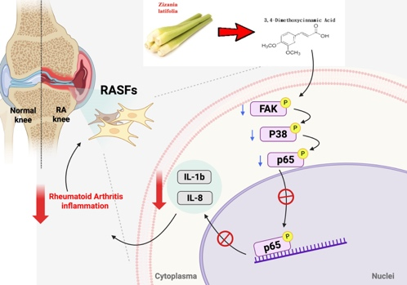
Results. Our data reveal significant expression of IL-1β and IL-8 in the synovial tissues of RA patients, contributing to synovial inflammation and arthritis formation. Treatment with 3,4-Dimethoxycinnamic acid inhibits the pro-inflammatory cytokines IL-1β and IL-8 expression levels in MH7A. Additionally, treatment with 3,4-Dimethoxycinnamic acid suppresses the inflammatory pathway (FAK/p38/NF-kB), leading to reduced expression of IL-1β and IL-8.
Discussion. Our data support clinical investigations using 3,4-Dimethoxycinnamic acid in RA disease
Reference: 1. Wang, M., et al., Characterization, antioxidant activity and immunomodulatory activity of polysaccharides from the swollen culms of Zizania latifolia. Int J Biol Macromol, 2017. 95: p. 809-817.

