Natural ginseng-derived nanoparticles for integrated anti-cancer strategies: Immune checkpoint enhancement and tumor vaccine delivery
Yali Liu¹, Haoran Wang¹, Meng Cao², Qingyun Wei², Peng Cao^{1,2,*}. State Key Laboratory of Technologies for Chinese Medicine Pharmaceutical Process Control and Intelligent Manufacture, Nanjing University of Chinese Medicine¹, Nanjing, China. Affiliated Hospital of Integrated Traditional Chinese and Western Medicine, Nanjing University of Chinese Medicine², Nanjing 210028, Jiangsu, China.

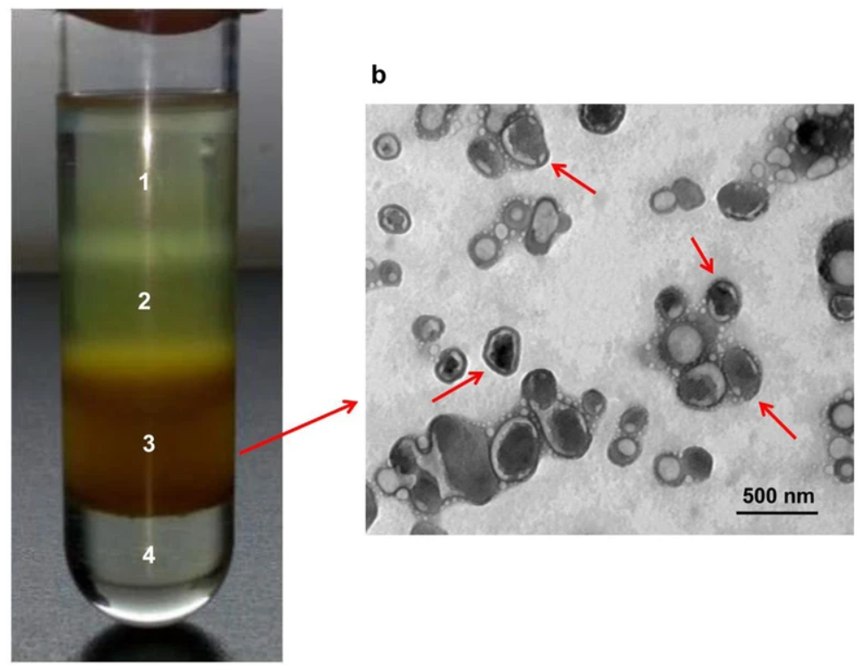
Introduction. Panax ginseng is a traditional medicinal herb widely used for its immunomodulatory and anti-cancer properties. Recent advances have highlighted ginseng-derived nanoparticles (GDNPs) as natural, biocompatible nanocarriers for drug delivery, offering low immunogenicity and intrinsic bioactivity. However, their application in cancer immunotherapy remains underexplored.
Aims. This study aims to establish a GDNP-based nanoplatform for cancer immunotherapy. Starting from enhancing anti-PD-1 efficacy, we extended its application to tumor peptide and whole-cell vaccine delivery. This multidisciplinary project promotes translation from concept to preclinical study.
Methods. GDNPs were isolated from fresh P. ginseng and characterized by TEM, NTA, and SDS-PAGE. We constructed three systems: GDNPs + PD-1 antibody, peptide-loaded GDNPs, and GDNPs carrying tumor lysates. Immune functions were evaluated via dendritic cell activation, T cell response assays, and tumor-bearing mouse models. Flow cytometry and IHC were performed to assess tumor immune modulation.
Results. GDNPs exhibited stable vesicular morphology and high compatibility. Co-treatment with PD-1 antibodies enhanced tumor suppression and T cell infiltration. Peptide-loaded GDNPs promoted antigen-specific T cell responses, while lysate-loaded GDNPs triggered robust anti-tumor effects. Increased CD8⁺ T cell presence and cytokine expression indicated effective immune reprogramming in the tumor microenvironment.
Discussion. GDNPs function as multifunctional and scalable carriers integrating immune checkpoint modulation and vaccine delivery. Compared to synthetic platforms, GDNPs provide natural bioactivity and reduced immunogenicity. These findings suggest promising clinical translational value for GDNPs-based immunotherapies in oncology.

