Conversion of labile ferric heme to NO-ferroheme has vasodilatory and anti-inflammatory effects
Anthony W DeMartino¹, David S Mahan¹, Elizabeth R Rochon¹, Qinzi Xu¹, Ruya Liu¹, Daniel B Kim-Shapiro², Mark T Gladwin¹. Department of Medicine, University of Maryland School of Medicine¹, Baltimore, MD, USA; Department of Physics/Translational Science Center, Wake Forest University, Winston-Salem, NC, USA.
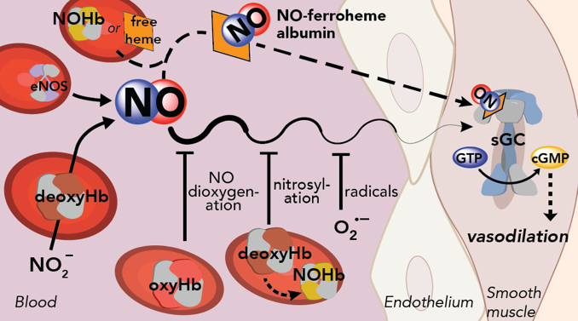
Introduction. The noncanonical activation of sGC by NO via reduction of nitrite by RBC hemoglobin is well established. However, intracellular and intravascular diffusion of NO are limited by scavenging reactions with several hemoproteins; how does free NO signal in hemoprotein-rich environments such as blood? A labile nitrosyl ferrous heme complex (NO-ferroheme) is formed by a physiologically available and rapid thiol-catalyzed reductive nitrosylation. NO-ferroheme resists oxidative inactivation, is soluble in membranes and transported intravascularly by albumin to promote potent vasodilation (DeMartino et al, Nat Chem Biol, 2023), ostensibly through direct activation of apo-sGC.
Aims. To determine the nature of NO-ferroheme formation in blood in normal and diseased states (e.g., sepsis or mimicked hemolysis). To confirm NO-ferroheme vasodilation, antiplatelet aggregation and apo-sGC activation.
Methods. MAP measurements in mice and platelet aggregation assays are in the above manuscript. Detection methods using updated, sensitive chemiluminescence techniques for NO-ferroheme formed in the vasculature are outlined in our new publication (DeMartino et al, Redox Biol, 2026), as well as detection in septic animals.
Results. NO-ferroheme can be detected in plasma down to 5 nM using NO chemiluminescence. Low to mid nM [NO-ferroheme] is detectable in the blood of septic animals, but not in healthy controls. IV injection of components for NO-ferroheme formation results in detection of NO-ferroheme in the plasma in healthy animals.
Discussion. For the first time, we show that NO-ferroheme is formed and detected in mouse plasma under various conditions including sepsis (where iNOS is highly upregulated). Its formation exhibits a host of anti-inflammatory properties, important in the context of hemolysis to counter Fenton chemistry and DAMP signaling from free heme.

