**Development and Performance Evaluation of Stimuli-responsive Nano-Formulations for the Management of Neurodegenerative Disease**

**Dilip Panwar1**, Dr. Prabhat Ranjan Mishra1,.

Division of Pharmaceutics and Pharmacokinetics, CSIR-CDRI1, Lucknow, Uttar Pradesh, India.

**Background and aims.** Neurodegenerative diseases are progressive conditions marked by the gradual loss of neuronal function and structure, often linked to aging. Disorders such as Alzheimer’s, Parkinson’s, and ALS involve cognitive decline, motor impairment, and inflammation. This study aims to develop ROS-responsive, selenium-based polymeric nanoparticles carrying a memantine-modified prodrug with antioxidant and anti-inflammatory properties for treating Alzheimer’s disease.

**Methods.** Memantine was chemically modified to form an isothiocyanate derivative (MEM-NCS) that releases hydrogen sulfide (H₂S) under physiological conditions and regenerates active memantine. The released H₂S provides antioxidant and anti-inflammatory effects, supporting neuroprotection. A ROS-responsive polymer (PEG-Se-PEG) was synthesized to formulate MEM-NCS-loaded micelles, which were incorporated into a thermoresponsive in-situ gel using poly-NIPAM for intranasal delivery. The formulation was evaluated for various parameters.

**Results.** The developed formulation transitions to a gel state at physiological temperature (37 °C). The synthesized ROS-responsive polymer self-assembled into micelles with an average diameter of ~173 nm and a polydispersity index (PDI) of 0.123. The critical micelle concentration (CMC) was determined using pyrene fluorescence and found to be 14.3 ppm. Upon exposure to 250 µM H₂O₂ for 3 hours, the micelles exhibited structural disassembly, confirming their responsiveness to oxidative environments. The encapsulated MEM-NCS prodrug effectively released hydrogen sulfide (H₂S) intracellularly, contributing to its therapeutic activity. Cytocompatibility assays conducted on BV-2 microglial cells at 10 and 50 µM doses indicated >90% cell viability for memantine, MEM-NCS, and the micelle formulation. Furthermore, both MEM-NCS and MEM-NCS-loaded micelles significantly improved cell survival in an Aβ₄₂-induced in vitro model of Alzheimer’s disease.

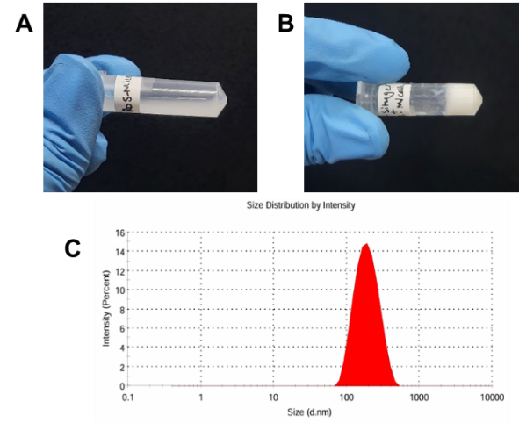

**Figure 1. A.** Reactive oxygen species (ROS)-responsive micelles encapsulating MEM-NCS; **B.** In situ thermoresponsive gel incorporating MEM-NCS-loaded micelles for intranasal administration; **C.** Particle size distribution profile of the optimized micellar formulation.

**Conclusion.** This study presents a novel ROS-responsive nanoformulation combining a MEM-NCS prodrug and polymeric micelles, designed to release H₂S in the CNS. It is the first memantine-derived system with dual antioxidant and autophagy-inducing properties, offering promising neuroprotective potential.

**References:**

1. Giovinazzo D, Bursac B, Sbodio JI, Nalluru S, Vignane T, Snowman AM, Albacarys LM, Sedlak TW, Torregrossa R, Whiteman M, Filipovic MR. Hydrogen sulfide is neuroprotective in Alzheimer’s disease by sulfhydrating GSK3β and inhibiting Tau hyperphosphorylation. Proceedings of the National Academy of Sciences. 2021 Jan 26;118(4):e2017225118.
2. Ren H, Wu Y, Ma N, Xu H, Zhang X. Side-chain selenium-containing amphiphilic block copolymers: redox-controlled self-assembly and disassembly. Soft Matter. 2012;8(5):1460-6.