Endothelium-dependent modulation of myogenic tone in coronary arteries
JinHeng Lin¹, Christopher J Garland¹, Kim A Dora¹. Department of Pharmacology, University of Oxford¹, Oxford, UK.

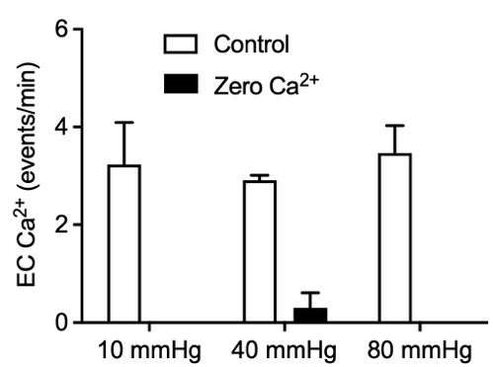
Introduction. Voltage-dependent processes set the pressure-driven tone of coronary arteries, seen as reversal of tone by inhibitors of voltage-gated calcium channels (CaV). This tone is suppressed by the spontaneous release of nitric oxide (NO) by the endothelium, yet the pathways remain unestablished.
Aims. To establish the mechanisms leading to the release of NO during myogenic tone in coronary resistance arteries.
Methods. Endothelial cell (EC) Ca²⁺ and arterial tone/tension were measured in isolated rat coronary septal arteries mounted for pressure and wire myography at 37 oC (Garland et al, 2017). Pharmacological agents were added to the chamber. Arteries were fixed at the completion of experiments for immunolabelling and RNAscope.
Results. EC Ca²⁺ was equally activated at 10, 40 and 80 mmHg, suggesting basal activation of NO suppresses myogenic tone. The activation was dependent on Ca²⁺ influx. Addition of an inhibitor of NO synthase causes depolarization and augmentation of myogenic tone (Ng H et al, 2024). A selective inhibitor of CaV3.2 T-type channels augmented vasoconstriction, whereas inhibitors of CaV1.2 L-type and pan CaV3.x T-type channels reduced myogenic tone. There is evidence for protein and mRNA expression of CaV channel isoforms in septal artery ECs alongside vascular smooth muscle cells.
Discussion. Understanding the pathways that lead to the intrinsic release of NO within the coronary microcirculation has implications for ischaemic heart disease associated with microvascular endothelial dysfunction.

Garland CJ et al (2017) Sci Signalling 486:1-14.
Ng YYH et al (2024) Hypertension 4:764-775.

