Tomentosenol A, isolated from bee propolis, inhibits TGF-β1/SMAD3 signalling in human fibroblasts
Lisa J Randall^{1,4}, Sarah Bajan^{1,2}, Trong T Tran^{3,4}, Robert J Harvey^{1,4}, Fraser D Russell^{1,4}. School of Health, UniSC¹, Sippy Downs, QLD, Australia; School of Biotechnology and Biomolecular Sciences, UNSW², Sydney, Australia; School of Science, Technology and Engineering, UniSC³; Centre for Bioinnovation, UniSC⁴, Sippy Downs, QLD, Australia.

Introduction. We isolated and purified a meroterpenoid from Australian stingless bee propolis, called tomentosenol A (Tom A). Tom A inhibited TGF-β1-stimulated proliferation, migration and differentiation of human fibroblasts (Hamilton et al, 2022), suggestive of an anti-fibrotic compound. The mechanism of action Tom A is to be determined.
Aim. To examine the mechanism of action of Tom A in cultured adult human dermal fibroblasts and HEK293 cells, with a focus on the SMAD2/3 signalling pathway.
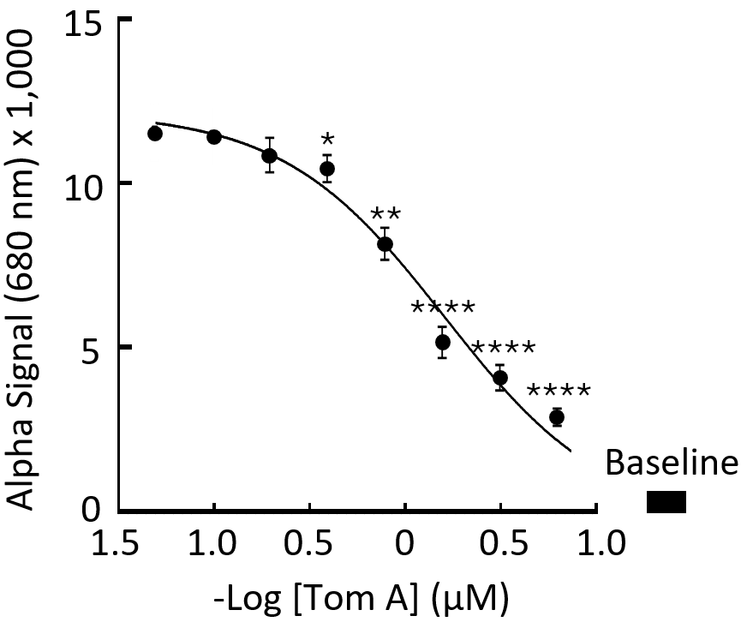
Methods. Normal adult human dermal fibroblasts were activated with TGF-β1 (10 ng/mL) in media containing DMSO (control), Tom A (0.05-6.25 μM), SIS3 (SMAD3 inhibitor; 10 μM) or GW788388 (TGF-βR1 inhibitor; 1 μM). Cell lysates were quantified for phosphorylation of SMAD3 (AlphaLISA assay), SMAD signalling (HEK293 cells expressing a SMAD3 reporter gene), and pro-fibrotic gene transcription (RTqPCR; ACTA2, COL1A1, COL3A, CCN2).
Results. TGF-β1 increased SMAD3 phosphorylation from baseline levels (Figure). Tom A (IC₅₀, 64.0 nM, n=3), SIS3 and GW788388 inhibited TGF-β1-stimulated SMAD3 phosphorylation. Tom A and SIS3 partially inhibited TGF-β1-stimulated SMAD3 reporter gene expression, while the combination of Tom A and SIS3 abolished the increased expression. TGF-β1 upregulated smooth muscle alpha actin (ACTA2), collagens 1A1 and 3A1 (COL1A1, COL3A1) and connective tissue growth factor (CCN2) transcription and this was reversed by 6.25 μM Tom A.
Discussion. The findings indicate inhibition of TGF-β1/SMAD3 signalling by Tom A. As this pathway is implicated in tissue fibrosis, Tom A is a compound that can be developed as a novel therapeutic approach for management of hypertrophic scars caused by deep dermal injuries that are associated with surgery, trauma, and burns.

Hamilton et al (2022) Antioxidants, 11:1604.

