Assessing the impact of Phenazopyridine on the efficacy of BCG-immunotherapy
Georgia Bourlotos¹, Meera Elmasri¹, Tanvi Narke¹, Steven Taylor², Alana White¹, Luke Selth¹, Giles Best¹, Luke Grundy¹. FHMRI, Flinders University¹, Adelaide, SA, Aus; SAHMRI², Adelaide, SA, Aus.
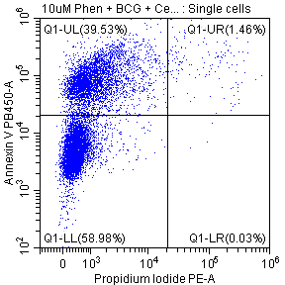
Introduction. Non-muscle invasive bladder cancer (NMIBC) is typically treated by Intravesical Bacillus Calmette-Guerin (BCG) immunotherapy. However, up to 70% of patients experience lower urinary tract symptoms (LUTS) including bladder pain, urinary urgency, and urinary frequency that significantly reduce quality of life during BCG treatment that can lead up to 20% of patients to cease therapy. Phenazopyridine (PAP) is urinary tract analgesic that is clinically effective in relieving LUTS during urinary tract infection. PAP could be effective in treating BCG-induced LUTS, however, whether it impacts with the efficacy of BCG needs to be established.
Aims. To determine whether PAP interferes with the therapeutic mechanism of action of BCG.
Methods. Urothelial cancer cell lines (MB49, T24 and UMUC3) were exposed to BCG (2hrs - 6.64x10⁵ CFU) in the absence and presence of PAP (10, 30, 100μM). Changes in BCG induced apoptosis and cytotoxicity were assessed by flow cytometry (Figure). Changes in BCG internalisation were quantified via qPCR, and immunohistochemistry (IHC). Mice (N=10) were treated with BCG (1.2x10⁷CFU) or BCG + PAP (300μM) once-weekly for six weeks. Mouse bladders were excised, and flow cytometry was used to characterise immune cell infiltration.
Results. BCG induces early and late apoptosis in vitro in urothelial cells (p<0.001) that is unaffected by PAP (p>0.05). qPCR and IHC reveals BCG urothelial cell internalisation is unaffected by PAP. Flow cytometry of BCG treated bladders shows PAP had no significant impact on infiltration of immune cell subtypes, including Neutrophils, Natural Killer cells and Dendritic cells
Discussion. This study shows that PAP, a urinary tract analgesic, does not significantly impact the apoptotic, internalisation, or immunogenic effects of BCG in vitro or in vivo. The results of this study indicate that PAP maybe be useful as an adjunct therapeutic to relieve LUTS associated with BCG therapy for NMIBC without impacting the mechanisms necessary for the efficacy of BCG.

