AI-Based Modeling of Aquaporin Transport for Renal Pharmacology and Drug Discovery Systems
Chitaranjan Mahapatra¹, Ashish Pradhan^{,2}. Bio Sciences & Bio Engineering, IIT Bombay¹, Mumbai, MAHARASHTRA, India; Department of Medicine, Harvard Medical School², Boston, MA, USA.

Aims. This study introduces an AI-driven computational model simulating aquaporin-mediated water transport, cell volume regulation, and membrane tension dynamics in renal epithelial cells. The goal is to uncover feedback mechanisms and identify therapeutic targets for pharmacological intervention.
Methods. We constructed nonlinear ordinary differential equations modeling cell volume, AQP gating, membrane tension, intracellular osmolarity, and stretch-sensitive potassium (K⁺) channel activity. Water flux was driven by osmotic gradients and AQP permeability, while K⁺ efflux responded to membrane tension. Python’s odeint handled numerical integration, and machine learning optimized biophysical parameters using physiological datasets.  Results. Simulations revealed a self-regulating feedback loop: increased AQP permeability led to water influx and cell swelling, which elevated membrane tension and activated K⁺ channels. The resulting K⁺ efflux and | 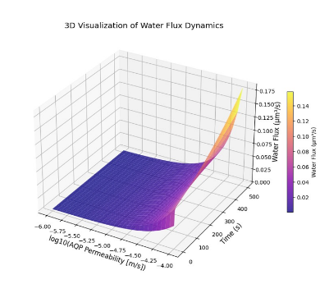
cell swelling, which elevated membrane tension and activated K⁺ channels. The resulting K⁺ efflux reduced intracellular osmolarity, stabilizing cell volume. Figure 1 illustrates this dynamic interaction, showing nonlinear relationships between AQP permeability, water flux, and cell volume. Stretch-activated K⁺ channels exhibited threshold-dependent gating behavior, acting as key modulators in reversing osmotic swelling.
Discussion. This AI-enhanced model highlights how AQPs and mechanosensitive K⁺ channels regulate renal epithelial volume. AQP antagonists may reduce water reabsorption in SIADH, while agonists could restore function in diabetes insipidus. K⁺ channel modulators offer therapeutic potential. The model supports pharmacological screening and drug discovery targeting renal water balance.

