**Optical properties of multilayered free-standing porous silicon microstructures for thermal imaging applications**

*Yaman Afandi[1]* , Giacinta Parish, and Adrian Keating*

School of Engineering, University of Western Australia, Perth, Western Australia, Australia.

**Introduction**

It is well known that to achieve a high index contrast in multilayered optical distributed Bragg reflectors (mirrors) a combination of different materials is required (Liu *et al.* 2012). While this approach is acceptable at short wavelengths, the issue of finding compatible materials in the long wave infrared (LWIR) spectrum has prevented the development of high-quality mirrors. In this work, a single material, porous silicon (PS), is proposed to create a tunable optical filter to overcome this issue by tailoring the refractive index during a simple electrochemical anodic etching process.

**Methods**

Multilayer released PS microstructures (beams and membrane structures) were built from PS layers fabricated by electrochemical etching in a solution of 25% hydrofluoric (HF) acid in ethanol, using a current density ranging from 10 to 130 mA/cm2 for low porosity (refractive index = 1.84) to high porosity (refractive index = 1.23). Boron-doped, 2” Si wafers (100) with thickness 275 μm±25 μm were used as a substrate. The process utilised a combination of different photolithographic and HF electropolishing steps which were developed based on a previous process to release a single PS layer (Sun *et al*. 2017).

**Results**

Fig.1a shows a full fabricated PS wafer and Fig. 1b the top view of a single membrane of 500×500-µm2 area. The openings at the corners allow HF ingress to the underlying layers during etching as well as providing stress relief on the otherwise square membrane. The HF electropolishing step removes the square area underneath the membrane, which can be seen through the semi-transparent PS in the SEM image as a different shade. The anchor was protected from HF etching during electropolishing by filling the pores with photoresist. The cross section in Fig.1c shows a filter designed to operate at a wavelength of 10 µm. The top mirror of the membrane consists of three layers of PS with refractive index ranging between 1.84 and 1.23, the air gap is 2 µm, and the bottom mirror is the Si substrate. Studies are currently ongoing to adjust the air gap space and create a second PS mirror on the fixed substrate to improve the transmission spectra. The model in Fig.1d is calculated for two mirrors of three layers of PS with 3-7 µm air gap, to allow tuning over a wide range of LWIR transmission.

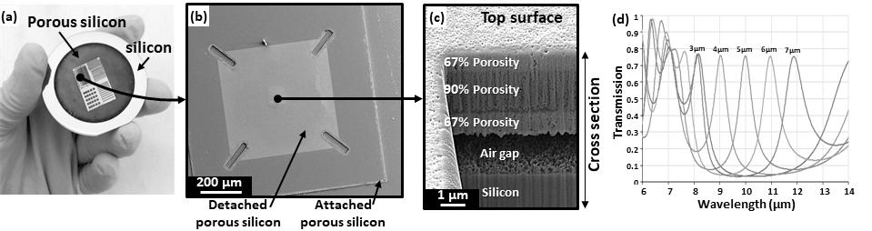

**Fig. 1 (a) Fully fabricated PS microstructures on 2” silicon wafer. (b) SEM top view and (c) cross-sectional view of a membrane with 2 µm air gap. (d) Modelled Transmission spectra of the membrane with air gap ranging from 3-7 µm.**

**Conclusions**

A released large area Fabry-Perot optical filter was made from PS and designed for LWIR operation. The preliminary data shows a robust, multilayer mirror made of one single material that could improve the performance of thermal imagers.

**References**

Liu, A., Zhu, W., Tsai, D., Zheludev, N., J. Optic. 14 (2012): 114009.

Sun, X., Parish, G., Keating, A., J. Micromech. Microeng. 27(2017) 044001.

1. * Corresponding author. Email: yaman.afandi@research.uwa.edu.au