Assessing ultra-processed food effects on energy metabolism in THLE-2 liver cells
Rhianna K. Lenham, David A. Barnes, Mark D. Berry, Scott V. Harding, Department of Biochemistry, Memorial University, St Johns, NL, Canada.

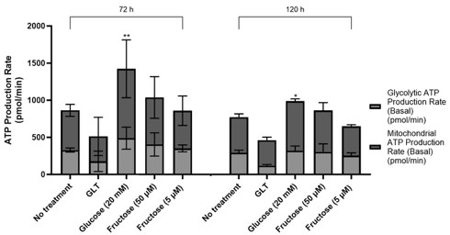
Introduction. Diets high in ultra-processed foods (UPF) are increasingly linked to metabolic disorders including obesity and type-2 diabetes. These conditions can impair liver function due to its central role in glucose and lipid metabolism. Fructose, common in UPF, is primarily metabolized in the liver, to glycolytic and fatty acid intermediates. This, however, bypasses glycolytic regulation whilst promoting fatty acid and triglyceride synthesis. Fructose has also been shown to promote oxidative stress, insulin resistance and hepatic lipogenesis; however, the molecular mechanisms remain poorly understood.
Aims. To determine the effects of fructose, glucose and fatty acid exposure on the metabolic profile of THLE-2 liver cells. Methods. A Seahorse™ XFe24 Analyzer (Agilent, Santa Clara, USA) was used to assess real-time, live cell, glycolytic and mitochondrial adenosine triphosphate (ATP) production by THLE-2 cells in response to various nutrient states. Exposure to high glucose (20 mM), fructose (5 and 50 ∝M) and glucolipotoxicity ((GLT) as a positive control comparator) for 0 – 120 h were explored. Following treatment, 10,000 viablecells wereseededintoa Seahorse™24-well platefor metabolic analysis. Statistical variances were determined via one-way ANOVA with Dunnet’s post-hoc tests.
Results. No significant differences were observed in mitochondrial or glycolytic ATP production rates at time points less than or including 24 h. High glucose significantly increased mitochondrial ATP production, without affecting glycolytic ATP production, at 72 and 120 h, whereas fructose treatment had no effect. Treatments administered only during analysis did not affect ATP production indicating effects are due to chronic regulation of metabolic pathways. Conclusions. High fructose exposure does not elicit the same metabolic response in THLE-2 cells as high glucose or GLT, suggesting fructose may influence hepatic metabolism via fatty acid oxidation rather than directly enhancing glycolysis via fructose metabolites. Comparison of high glucose to GLT confirms previous findings that GLT effects observed are due to the presence of fatty acids. Future work will specifically examine palmitate oxidation and mitochondrial reactive oxygen species tolerance in response to high fructose.

