CFTR modulator bidirectional transport through CLEFF4 monolayers, evidence of P-gp substrate affinity
Andrew Crowe^{1,2}. Curtin Medical School, Curtin University¹, Perth, WA, Australia and Curtin Health Innovation Research Institute (CHIRI), Curtin University², Perth, WA, Australia.
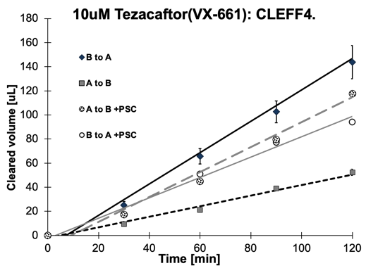
Introduction. Cystic Fibrosis (CF) is a clinical manifestation of mutations in the cystic fibrosis transmembrane conductance regulator (CFTR) gene leading to a Chloride transport protein that does not function adequately. One of the current drug therapies for CF is the CFTR modulator class of drug, that restores functionality to the CTFR protein. Aims. As these are a relatively new class of drug, very little is known about their affinity for the efflux system, P-glycoprotein (P-gp). As there are new studies suggesting CFTR drugs can traverse sensitive sites causing problems, such as within the brain, or into a developing foetus or secretion into breast milk, this small study was done to explore P-gp mediated efflux of the 4 main CFTR modifiers currently in use today. Methods. The rapid CLEFF4 sub clone of Caco2 cells used for P-gp efflux and diffusion characteristics of drug movement across human epithelial barriers was used at 6 days of growth to determine apparent permeabilities (Papp) from bi-directional transport of 4 CFTR modulators. These being, Ivacaftor, Elexacaftor, Lumacaftor and Tezacaftor. These drugs were used at the lowest concentration possible that could still be measured by optimised UV-HPLC methods using an Agilent 1100 series HPLC, which allowed 10-20 micromolar concentrations to be used. Results. Only Tezacaftor was shown to be a P-gp substrate in this study with Papp of 12x10⁻⁶ cm/sec shown in the apical (Ap) to basolaterial (Bas) direction and 36x10⁻⁶ cm/sec in the reverse direction (see Fig). When P-gp was inhibited by PSC-833, transport increased to over 28x10⁻⁶ cm/sec in apical direction and reduced to 23x10⁻⁶ cm/sec in the reverse. This reduced the efflux ratio from 3.0 to 0.8.
Discussion. Tezacaftor is affected by P-gp, such that high P-gp levels in tissue barriers will reduce drug concentrations. However, Elexacaftor and Lumacaftor are unaffected and would have likely higher concentrations in the brain, testes and access to a foetus, increasing adverse effects compared to Tezacaftor. Ivacaftor was not measurable through even empty filter inserts suggesting it would be difficult to interpret any direct movement of this drug in vivo or in vitro.

