Assessment of demand for male contraceptives: a multi-country study
Steve Kretschmer, DesireLine, Istanbul, Turkiye

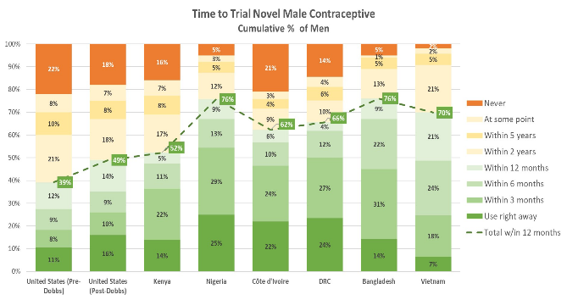
Introduction. Despite high rates of unintended pregnancy and increasing interest in shared contraceptive responsibility, male options remain extremely limited. While new methods are in development, few studies offer rigorous, population-level insight into male demand or partner trust.
Aims. To generate robust, multi-country evidence on men’s willingness to use novel male contraceptives and to identify the product features that most influence uptake intent, critical for informing product development, policy, and investment.
Methods. A probability-based, cross-sectional survey was conducted with 12,435 sexually active, fertile cisgender men aged 18–60 and 9,122 of their female partners across six LMICs (Bangladesh, Vietnam, Kenya, Nigeria, DRC, Côte d’Ivoire), and in the U.S. (n=3,243), with a follow-up (n=3,070) post-Dobbs. The survey included contraceptive use, fertility intentions, and perceptions. A discrete choice experiment (DCE) evaluated preferences for 11 male contraceptive attributes across 52 levels. Analyses included conditional logit models, chi-square tests, and z-tests to assess subgroup variation and timepoint changes.
Results. On average, 61% of men would try a novel male method within a year of availability, ranging from 39% (U.S. pre-Dobbs) to 76% (Nigeria, Bangladesh). Form of administration was the strongest driver of preference, followed by STI protection and onset time. Side effects mattered less. Post-Dobbs, U.S. willingness rose significantly. Female trust was high, though many preferred to continue their own method.
Discussion. There is strong global interest in novel male contraceptives, especially in LMICs. Preferences for familiar, non-invasive methods and high female trust suggest promising uptake if products align with user needs.

Kaur J, Rohini DV, Chang L, Gugliotti A, Kretschmer S. Assessment of demand for male contraceptives: A multi-country study. Andrology. 2024 Oct;12(7):1512-1524. doi: 10.1111/andr.13726. Epub 2024 Aug 19. PMID: 39158308.

