Structural and molecular basis of choline uptake into the brain by FLVCR2
Rosemary Cater^{1,2}*, Dibyanti Mukherjee³, Eva Gil-Iturbe⁴, Matthias Quick^{2,4}, Thomas Arnold³*, Filippo Mancia²*

¹ Institute for Molecular Bioscience, The University of Queensland, St. Lucia, QLD, Australia.
² Department of Physiology and Cellular Biophysics, Columbia University, New York, NY, USA.
³ Department of Paediatrics, University of California San Francisco, San Francisco, CA, USA.
⁴ Department of Psychiatry, Columbia University Irving Medical Center, New York, NY, USA.

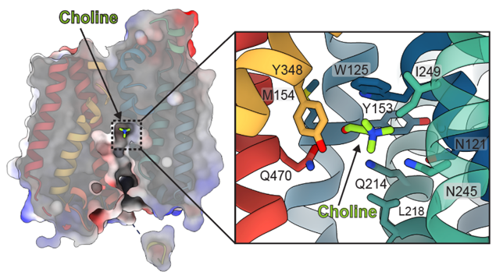
Introduction. Choline is an essential nutrient that the human body needs in vast quantities for cell membrane synthesis, epigenetic modification, and neurotransmission. The brain has a particularly high demand for choline, but how it enters the brain has eluded the field for over fifty years. The MFS transporter FLVCR1 was recently determined to be a choline transporter, and while this protein is not highly expressed at the blood-brain barrier (BBB), its relative FLVCR2 is. Previous studies have shown that mutations in human Flvcr2 cause cerebral vascular abnormalities, hydrocephalus, and embryonic lethality, but the physiological role of FLVCR2 is unknown.
Aims. To determine the physiological function of FLVCR2 and structurally characterise its transport mechanism.
Methods. In vivo mouse models, in vitro cell-based and cell-free transport assays, cryo-electron microscopy (cryo-EM).
Results. Here, we demonstrate both in vivo and in vitro that FLVCR2 is a BBB choline transporter and is responsible for the majority of choline uptake into the brain. We also determine the structures of choline-bound FLVCR2 in the inward- and outward-facing states using cryo-EM to 2.49 and 2.77 Å resolution, respectively.
Discussion. These results reveal how the brain obtains choline and provide molecular-level insights into how FLVCR2 binds choline in an aromatic cage and mediates its uptake. Our work could provide a novel framework for the targeted delivery of neurotherapeutics into the brain.

Do not change the margins, the font, size or any other setup on this template. The abstract should be left-and right-justified. Line spacing must be single. The abstract must be one A5 page only. The abstract must be typed in Calibri 10 point. Do not use bold in the abstract text, only the title should be in bold. As abstract pages may be printed in black and white only, you may consider including tables and images in greyscale. Please pay particular attention to these instructions as abstracts that do not conform will not be accepted by the editors.

The text should be as informative as possible. If you have any problems please call Expert Events on +61 7 3848 2100 or wcp2026@expertevents.com.au.

McCartney P (2001) J J 56:23-33
Starr R et al (2005) Pharmacology of FAB-4, ed Ono Y. pp 12-23, Tokyo, Abbey Road Press

