**Modulation of Aspirin Pharmacokinetics by Traditional Herbal Medicines: A Clinical Study of Ijintang and Cheongsanggyeontongtang**

Ju Hee Kim1, Minji Kim1, Jungbin Song2, Sang Won Lee3, **Hea-Young Cho1**

1College of Pharmacy, CHA University, Seongnam-si, Gyeonggi-do, Republic of Korea

2Department of Herbal Pharmacology, College of Korean Medicine, Kyung Hee University, Seoul, Republic of Korea

3Department of Clinical Pharmacology and Therapeutics, Hanyang University Seoul Hospital, Seoul, Republic of Korea

**Background and aims.** Low-dose aspirin is routinely prescribed for secondary prevention of ischemic stroke. In Korea, it is often co-administered with traditional herbal medicines such as Ijintang (IJT) and Cheonsanggyeontongtang (CGT), especially among post-stroke patients. This study was conducted to examine whether IJT or CGT influence the pharmacokinetics (PK) of aspirin when used together.

**Methods.** An open-label, randomized, three-period, two-sequence, two-way crossover study involving 14 healthy Korean volunteers was conducted. Each participant received aspirin 100 mg alone and in combination with either IJT or CGT, following a 6-day pretreatment with the respective herbal medicine. Serial blood sampling was performed over 24 hours to assess plasma concentration of acetylsalicylic acid (ASA) and its metabolite salicylic acid (SA). Quantification was carried out using validated LC-MS/MS, and noncompartmental PK analysis was performed with Phoenix WinNonlin®.

**Results.** When aspirin was taken with IJT, a trend toward increased ASA exposure (AUClast geometric mean ratio [90% CI]: 1.44 [0.75-2.73]) and decreased SA exposure was observed. In contrast, CGT co-administration showed reduced ASA exposure (0.77 [0.41-1.45]) and marginally elevated SA exposure.

1. **(B)**

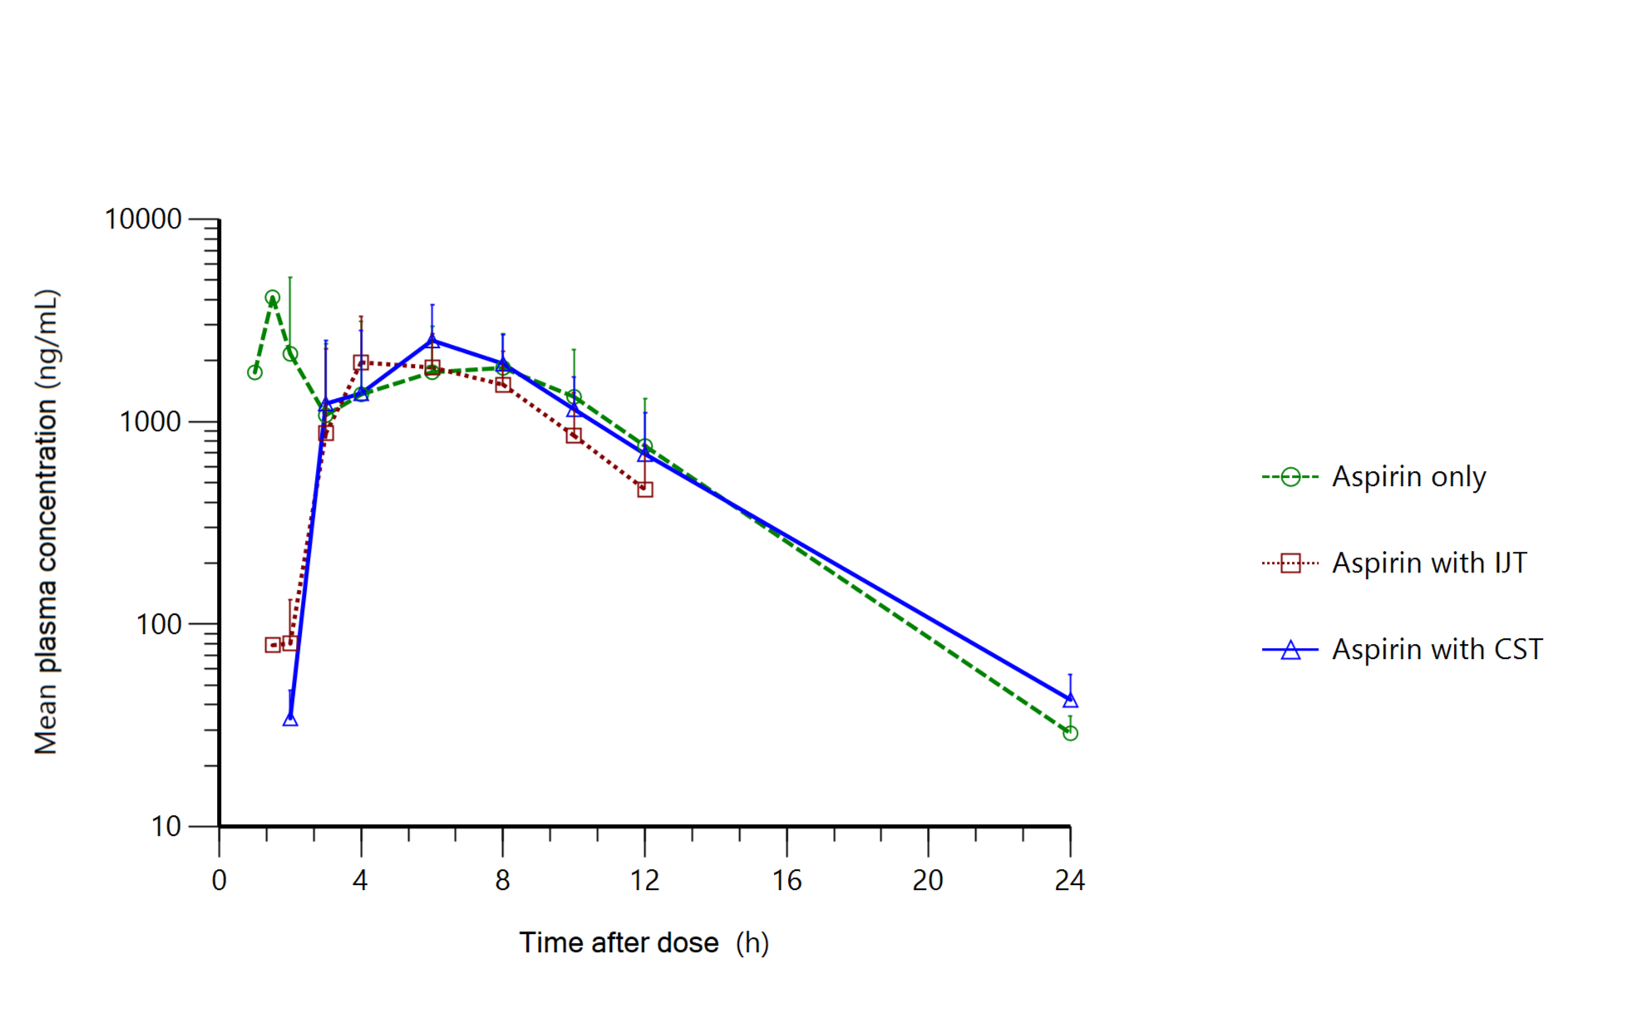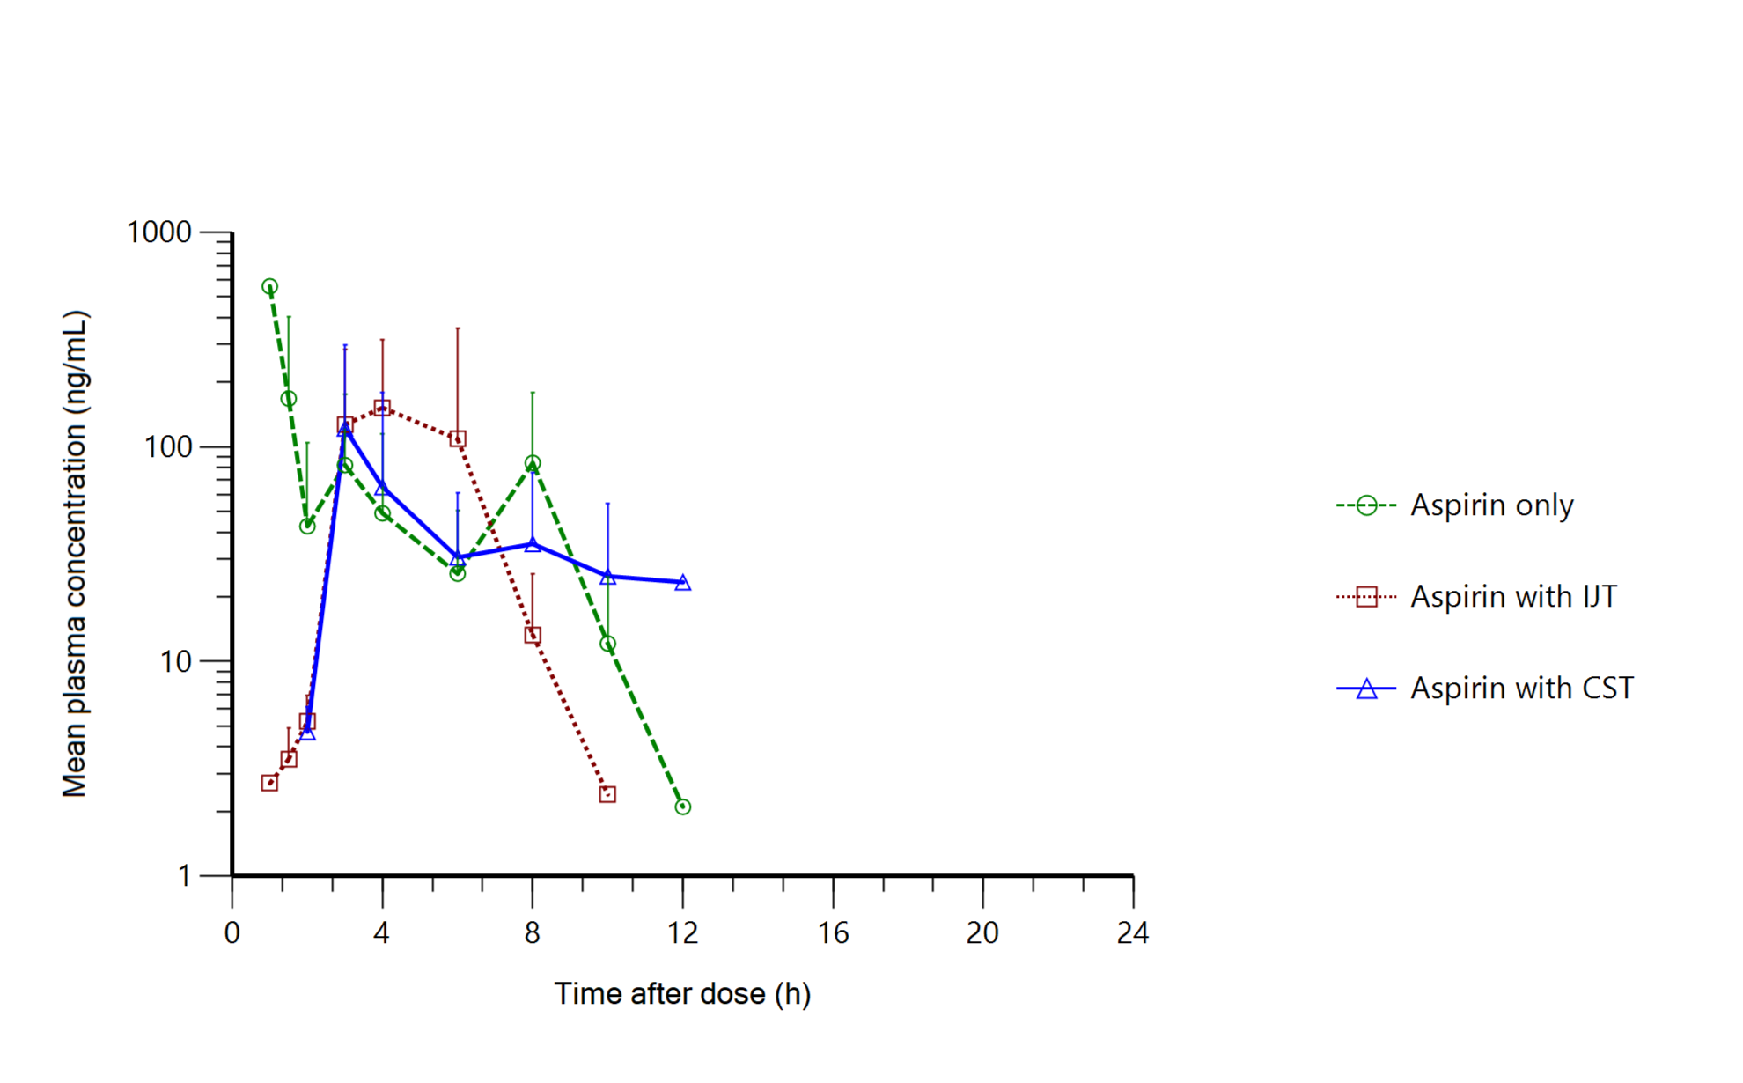

**Figure 1.** Mean plasma concentration-time profiles of (A) aspirin and (B) salicylic acid after administration of aspirin alone (green circle, dashed line), co-administration of aspirin and Ijintang (IJT) (red square, dotted line), co-administration of aspirin and Cheongsangyeontong-tang (CST) (blue triangle, solid line). Error bars represent standard deviations.

**Conclusion/Discussion.** Although the observed changes in aspirin pharmacokinetics did not reach statistical significance, the directional differences indicate that IJT and CGT may differently affect aspirin metabolism. These findings provide a valuable foundation for developing clinical guidelines on the co-administration of aspirin with traditional herbal medicines.

**Acknowledgements** This research was supported by a grant of the Korea Health Technology R&D Project through the Korea Health Industry Development Institute (KHIDI), funded by the Ministry of Health & Welfare, Republic of Korea (grant number: RS-2020-KH087681).

**References:**

(1) Han, S.-R. et al (2011) J.Ethnopharmacol 151(3), 1209-1217

(2) Cho, S-j. (2025) J.Ethnopharmacol 337(3), 118997